Upward Bound Summer 2007 Final ●

Part I: Basic statistics

On Sunday 08 July 2007 the Honolulu Advertiser ran an article covering the rising number of Micronesians using Hawaii's homeless shelters. The number soared by nearly three times between 2001 and 2006, and Micronesians now make up more than 20 percent of the state's total homeless population. Many of these homeless Micronesians are families from the FSM who cannot afford the high cost of housing in Hawaii.

Year | Number of Micronesians in homeless shelters in Hawaii
2001 | 286
2002 | 316
2003 | 554
2004 | 463
2005 | 513
2006 | 736

Use the number of Micronesians in homeless shelters in Hawaii for the following calculations. Do not use the year data!
1. __________ Find the minimum for the number of Micronesians in homeless shelters in Hawaii.
2. __________ Find the maximum for the number of Micronesians in homeless shelters in Hawaii.
3. __________ Find the range for the number of Micronesians in homeless shelters in Hawaii.
4. __________ Find the mode for the number of Micronesians in homeless shelters in Hawaii.
5. __________ Find the median for the number of Micronesians in homeless shelters in Hawaii.
6. __________ Find the mean (average) for the number of Micronesians in homeless shelters in Hawaii.
7. __________Overall is the number of Micronesians in homeless shelters in Hawaii increasing, decreasing, or staying about the same over the time period shown above?

Part II: Number Bases

Matching. Match the color to the correct hexadecimal RGB color command. Write the letter of for the correct hexadecimal RGB color command next to the color.

Color | Hexadecimal RGB color command
8. _____ Black | A. #000
9. _____ Blue | B. #00F
10. _____ Green | C. #0F0
11. _____ Red | D. #F00
12. _____ White | E. #FFF
13. __________ What is 4 + 4 in base 5 (pental)?
14. __________ What is 6 + 6 in base 16 (hexadecimal)?
15. __________ What is B + B in base 16 (hexadecimal)?

Part III: Linear equations and linear regressions

Young boys in Dolokei, Nett recorded the following data for a peisihr throwing stick thrown along the road. A peisihr stick sliding on a road is like walking at a steady pace on a road.

time/sec (x) | distance/meters (y)
0 | 0
0.6 | 10
1.2 | 20
1.8 | 30
16. Plot the data above on the graph:
Formulas
Slope | Point-slope | Slope-intercept
17. slope m = __________ Determine the slope of the best fit line.
18. y-intercept = ________ Determine the y-intercept of the best fit line.
19. ____________________ Write out the slope-intercept equation for the line.
20. ________ If the peisihr stick travels for 2.4 seconds, how far will it go?
21. ________ How long does it take the peisihr stick to travel 55 meters?
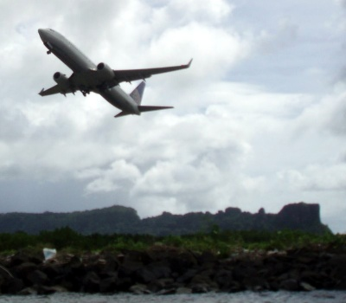
Part IV: Quadratic equations:

A Continental Micronesia 737-700 rolling down a runway at takeoff accelerates like a ball rolling down a slope. The following time and distance data was recorded for a Continental Micronesia plane taking off from Daketik:

time/sec (x) | distance/meters down the runway (y)
0 | 0.0
5 | 100
10 | 400
15 | 900

22. Fill in the following table by squaring the times in the table above:

time²/sec² (x) | distance/meters (y)
 | 0
 | 100
 | 400
 | 900

OpenOffice.org Calc Formulas

slope | =slope(y-values;x-values)
y-intercept | =intercept(y-values;x-values)
23. slope m = __________ Determine the slope of the time²/sec² versus distance/meters line. You can use the OpenOffice.org to assist you.
24. y-intercept = ________ Determine the y-intercept of the time²/sec² versus distance/meters line.
25. y = ________ x² + __________ Write out the quadratic equation.
26. _________________ How far will the aircraft have traveled in 20 seconds?

Photograph by D. C. Meyer, taken on 10 May 2007, Pohnpei FSM.
Part V: Ball Arc

A ball is thrown through the air as seen in the diagram below.
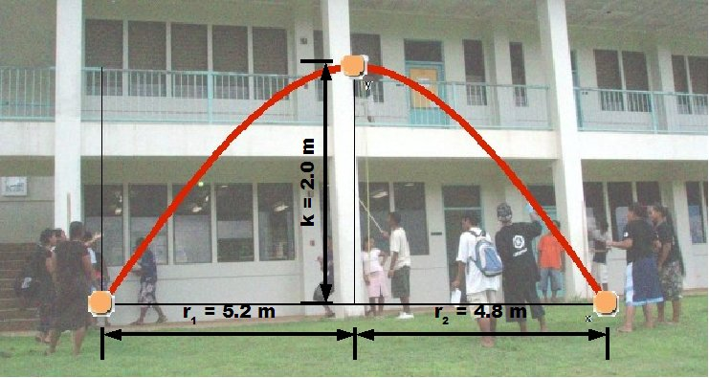
Note that in the diagrame r₁ = 5.2 meters, r₂ = 4.8 meters, and k = 2.0 meters.

The equation of the arc of the ball in the air is give by:
27. k = ________ Use the diagram to determine the y-intercept k.
28. r = ________ Use the diagram to find the average distance of the roots r by calculating
29.Write out the equation of the arc of the ball: y = ____________ x² + _____________

Part VI
30. _______ How many balls are used in the site swap pattern 423?
31. _______ How many balls are used in the site swap pattern 51?

