PreSophomore Algebra 1 (29 Students) Test five Name:
version: 200607191336

1. ____________________ Factor the trinomial x² + 11x + 30.25

2. _________ _________ Solve for x: x² + 11x + 30.25 = 0

3. _________ _________ Solve by completing the square: x² + 54x + 713 = 0

4. _______________ Find the prime factorization of 377

5. _______________ Find the prime factorization of 80040

6. _______________ Find the prime factorization of 9409

7. _______________ Find the greatest common factor of 1596 and 3276.

8. _________ Solve for x: 21x + 987 = 0

9. _________ _________ Factor as fully as possible: 1596x² − 3276x

10. _________ _________ Solve for x: 1596x² − 3276x = 0

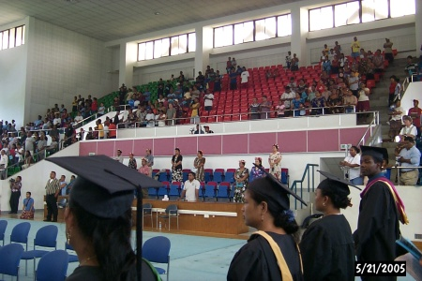
On the national campus of the College of Micronesia-FSM is a large gymnasium. The number of seats inside the gymnasium remains uncertain. Every one who has counted the seats has arrived at a different number. In the spring of 2005 the MS 095 PreAlgebra students at the national campus tackled the problem and came up with the following data:

Team | Seat count
Kiumy, Caroline (Felicen) | 1151
Anastasia | 1307
Agnes | 1430
A-1, Albert | 1322
Kesarina, Meranda | 1419
Sylvia, Sedora | 1291

11. _________ Find the mode for the above data.

12. _________ Find the median for the above data.

13. _________ Find the mean (average) for the above data.

14. _________ Find the range for the above data.

