PreSenior Algebra 2 test four (25 Students) Name:
version: 200607130915

1. Give the name of the following shapes:

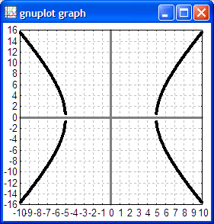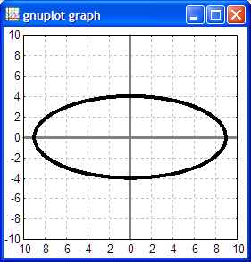

2. For each of the following equations, write the name of the shape formed by the equation:

a. b. c.

d. For the parabola above, algebraically rearrange the equation to find the vertex form (y − k ) = a(x − h)²
Nota bene: Remember that if the vertex is at the origin then the equation reduces to y = ax ²

e. For the parabola above, given the general vertex-focus form is: , find the value of p.

f. For the parabola above, write the vertex in (h, k) form.

g. For the parabola above, make a rough sketch using the back of this paper.

h. For the circle above, write the center in (h, k) form.

i. For the circle above, find the radius r.

j. For the circle above, make a rough sketch using the back of this paper.

k. Give an example of a physical system in which ellipses occur.

l. Give an example of a physical system in which parabolas occur.

3. For find the vertical asymptote.

