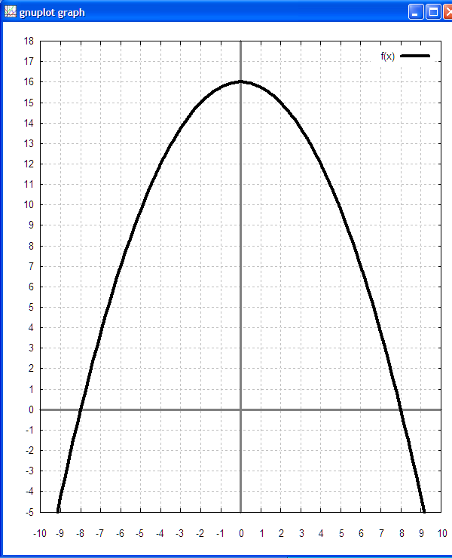
PreSenior Algebra 2 test two (25 Students) Name:
version: 200606281955

1. For the function fill in the table below and plot the (x, y) coordinates on the graph at the right.

x | y
−5
−4
−3
−2
−1
0
1
2
3
4
5

The graph of the marble path at the right has the form .
2. __________ Determine k for the function on the right.
3. __________ Determine r for the function on the right.
4. Write the function for the graph on the right.

y =

5. _______________ Factor x² − 8x + 16.
6. _____ _____ Solve for x: x² − 8x + 16 = 0

7. _______________ Factor x² − x −110
8. _____ _____ Solve for x: x² − x −110 = 0

9. _____ _____ Solve for x by completing the square: x² + 8x − 8633 = 0

10. _____ _____ Super toughie! Solve for x by completing the square: 2.5x² − 15x + 5 = 0

