f(x) = x⁴−8x²+16 g(x)= x³+3x²−88x h(x)= x³−4x²−17x+60
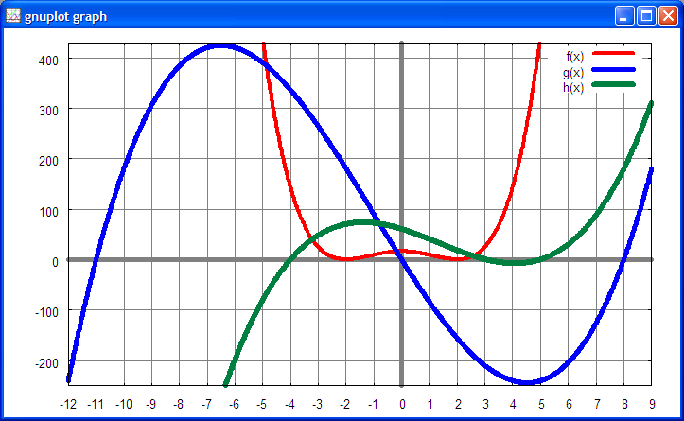
i(x)=x⁵−45x³+324x j(x)=−x⁶+14x⁴−49x²+36 k(x)=x⁶−54x⁴+825x²−2500
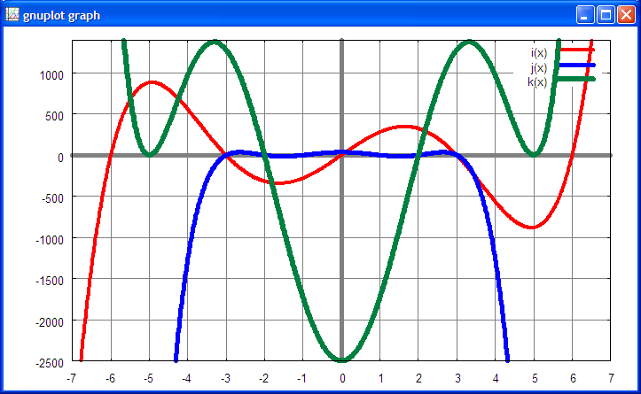

(%i1) solve([x^4-8*x^2+16=0], [x]);
(%o1) [x=-2,x=2]
(%i2) solve([x^3+3*x^2-88*x=0], [x]);
(%o2) [x=-11,x=8,x=0]
(%i3) solve([x^3-4*x^2-17*x+60=0], [x]);
(%o3) [x=-4,x=3,x=5]
(%i4) solve([x^5-45*x^3+324*x=0], [x]);
(%o4) [x=-3,x=3,x=-6,x=6,x=0]
(%i5) solve([-(x^6)+14*x^4-49*x^2+36=0], [x]);
(%o5) [x=-1,x=1,x=-2,x=2,x=-3,x=3]
(%i6) solve([x^6-54*x^4+825*x^2-2500=0], [x]);
(%o6) [x=-5,x=5,x=-2,x=2]

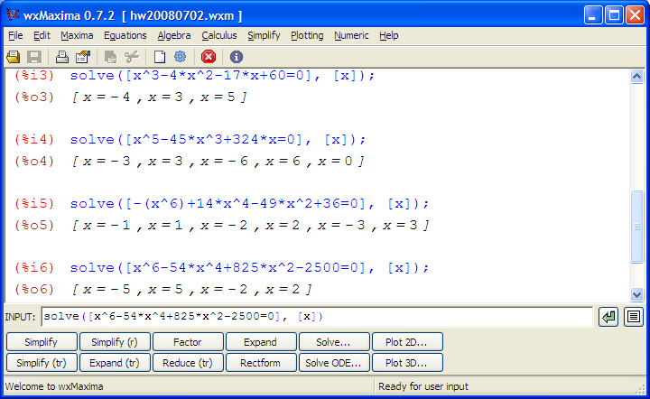
Gnuplot commands:
reset
set border
set xtics 1
# set ytics 100
set ytics 500
set xzeroaxis lt 9 lw 5
set yzeroaxis lt 9 lw 5
set style line 1 lt 1 lw 4
set style line 2 lt 3 lw 5
set style line 3 lt 10 lw 6
set style line 4 lt 12 lw 3
set style line 5 lt 9 lw 1
set grid ls 5
show grid
# ranges for f(x), g(x), h(x)
# set xrange [-12:9]
# set yrange [-250:430]
set xrange [-7:7]
set yrange [-2500:1400]
set samples 1000
set key on
# f(x)=x**4-8*x**2+16
# g(x)=x**3+3*x**2-88*x
# h(x)=x**3-4*x**2-17*x+60
i(x)=x**5-45*x**3+324*x
j(x)=-x**6+14*x**4-49*x**2+36
k(x)=x**6-54*x**4+825*x**2-2500
# plot f(x) ls 1
# plot f(x) ls 1,g(x) ls 2, h(x) ls 3
plot i(x) ls 1,j(x) ls 2, k(x) ls 3

