MS 100 College Algebra Test Three Name:
file and version info: t3.odt 200706281150

Match the following three graphs below to the correct function below the graphs.
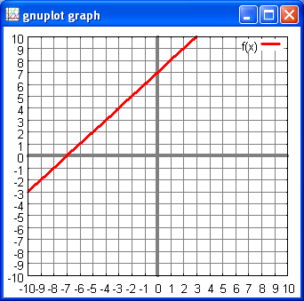
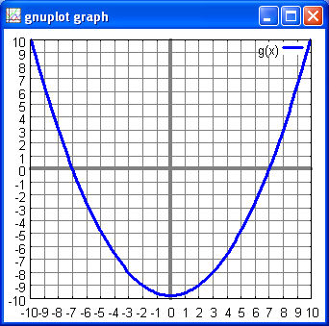
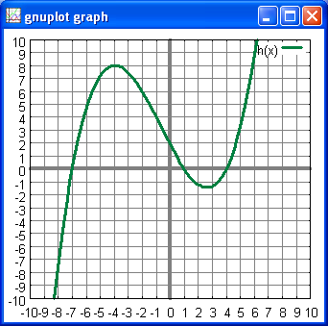
A. B. C

_______ 1. f(x) = x + 7
_______ 2.
_______ 3.

 | f(x) = x + 7
What is the name of the shape formed on a graph by the equation in the top row? | 4. | 5. | 6.
What is the degree of the equation in the top row? | 7. | 8. | 9.
Does the equation in the top row pass the vertical line test? | 10. | 11. | 12.
Does the equation in the top row pass the horizontal line test? | 13. | 14. | 15.
Is the equation in the top row a function? | 16. | 17. | 18.
Does the equation in the top row have an inverse function? | 19. | 20. | 21.

22. For the following questions use the three functions:
f(x) = 4x − 20 g(x) = −4x + 20

a. _________________________ Find

b. _________________________ Find

c. _________________________ Find (f + g)(x)

d. _________________________ Find (f − g)(x)

e. _________________________ Find (f × g)(x)

f. _________________________ Find (f ÷ g)(x)

g. _________________________ Find [g(x)]²

h. _________________________ Find

i. _________________________ Find

j. __________ Does the function f(x) pass the vertical line test?

k. __________ Does the function f(x) pass the horizontal line test?

l. _________________________ Find the inverse function

m. __________ Does the function g(x) pass the vertical line test?

n. __________ Does the function g(x) pass the horizontal line test?

o. _________________________ Find the inverse function

p. _________________________ Find:

23. A water wave in shallow water travels with a velocity v: where g is the acceleration of gravity and d is the depth of the water. The kinetic energy of a moving object is k(v) = where m is the mass and v is the velocity.
Find

24. [0 , _______ ] Find the y-intercept for

25. Find the zeros of the function

[ __________ , 0 ] [ __________ , 0 ]

26. Find the axis of symmetry for

axis of symmetry x = ____________

27. Find the vertex for

[ ________ , ______________ ]

28. On the chart provided above sketch a smooth graph of:

29. ________________ Is the curvature of positive or negative?

