MS 100 College Algebra test one summer 2007 Name:
Section 1.1: Graphs of equations

1. Sketch a smooth graph of :

2. Find the y-intercept for y = x² − 2x − 323

y = __________

3. Find the x-intercepts for y = x² − 2x − 323

x = __________ , __________

4. For the equation x² + y² = 289

a. What is the name of the shape of the graph?

b. r = __________What is the radius for the equation?

c. What are the coordinates of the center?

5. Write the equation for a circle centered on the origin with a radius of 12.5

Section 1.2 Equations and their solutions

6. Is x(x + 30) + 221 = (x +13)(x + 17) an identity or a conditional statement?

7. Solve for x: x = __________

8. Solve for x: x = __________

9. Given the surface area equation for a cylinder seen below, find the height h of the cylinder:

Section 1.3: Word problems.
10. __________ A dress without tufts (untufted) takes two hours for an experienced seamstress to sew. A dress with tufts (tufted) takes three and half hours to sew. What is the percentage increase in time for a tufted dress versus and untufted dress? Treat the untufted dress as the original amount and the tufted dress as the new amount in the percentage change formula.

11. __________ My wife sews untufted dresses for ten dollars. If she wants to charge the same rate per unit time for a tufted dress, how much should she charge? In other words, what is the new price if the original price is ten dollars and the percent increase is that determined in the previous problem?

For the following word problems, pace is defined as the time/distance.

12. __________ 06 June 2005 I covered 5.346 kilometers in 33.47 minute run from Piyuul to Fulkrin in Malem on Kosrae. Calculate my pace in minutes per kilometer.

13. __________ At the pace calculated in problem eight, how long would it take me to run the 12.62 kilometers from Piyuul, Malem to Inkoyac, Tafunsak?

Section 1.1: Graphs of equations
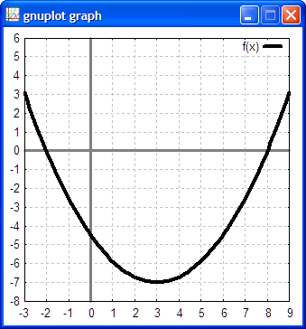
14. For the equation below, identify and list both the x-intercepts and the y-intercept. IF the value is not an exact integer value, then make a best estimate of the value.

y-intercept(s):

x-intercept(s):

