MS 100 College Algebra Midterm summer 2007 Name:
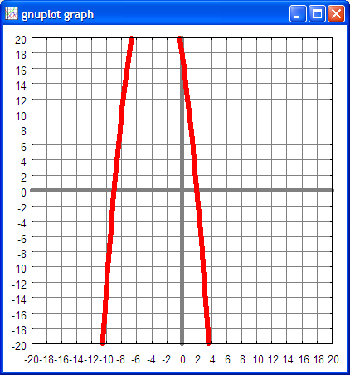
1. Sketch a smooth graph of
on the graph provided to the right. Use this graph for questions two to six.

2. Curvature: negative

3. On the graph, label the
y-intercept for the function sketched for question one.

4. On the graph, label the
x-intercepts for the function sketched for question one.

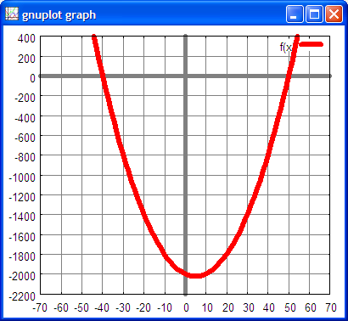
5. On the graph, draw in the axis of symmetry for the function sketched for question one.

6. On the graph, label the vertex for the function sketched for question one.
(my bad – allowances were made on this one! )

7. For the function depicted on the right, what is the y-intercept?

y = –2000

8. For the function depicted on the right, what are the x-intercepts? Note the x-axis scale at the bottom of the graph.

x = ( –40, 0 ) ( 50, 0)

9. Given that the lead coefficient on the x² term is one, what is the function that generated the graph above?
f(x) = x² – 10x – 2000

10. Find the zeros of the function :

x = ( –9, 0 ) x = ( 2, 0 )

11. Solve for x:

x = 17.5 x = 14.5

12. Solve for x:

x = 4 – 7i x = 4 + 7i

13. Solve for x and write the answer on a number line:

x < –17

14. In April 2007 the national campus consumed 134,316 kilowatt-hours of power. In May 2007 the national campus consumed 105,391 kilowatt-hours. What is the percentage change from April to May?
percentage change = – 21.5%
15. Isan equation or a function? function

16. Find the y-intercept for y = – 238
17. Find the axis of symmetry for x = 1.5

18. Find the zeros for

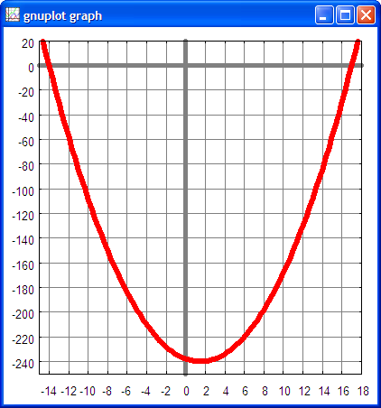
x = ( –14, 0 ) x = ( 17, 0 )

19. Find the vertex for

( 1.5 , – 240.25 )

20. Is the curvature positive or negative for ?

positive

