Homework due 15 June 2007

1. y = x² + 52x + 667
a. y-intercept: 667

b. x-intercepts: -29, -23

x² + 52x + 667 = 0
x² + 52x = -667
x² + 52x +676 = -667 + 676
(x + 26)(x + 26) = 9
(x + 26)² = 9
x + 26 = ±3
x = -26 ± 3

c. axis of symmetry: x = -26
d. vertex: (-26, -9) [by substitution of -26 into the original equation]

2. y = -x² + 6x + 24.0625
a. y-intercept: 24.0625
b. x-intercepts: x=-11.75, x=8.75
c. axis of symmetry: x = 3
d. vertex: (3, 33.0625)

3. y = x² +5x + 61
a. y-intercept: 61
b. x-intercepts:
c. axis of symmetry: x = -2.5
d. vertex: (-2.5, 54.75)

4. y = 4x² + 40x + 84
a. y-intercept: 84
b. x-intercepts: -3, -7
c. axis of symmetry: x = -5
d. vertex: (-5, -16)

5. The sketch of the graph had roots at (-2, 0 ) and (7,0). Thus x = -2 and x = 7. This implies a factorization of (x + 2)(x – 7) = 0. The generating equation must have been:
y = x² - 5x – 14

Sketches for one to four:
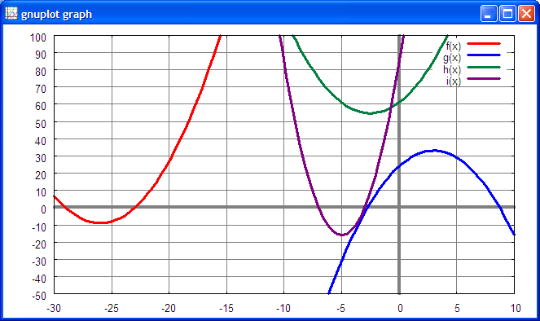

Maxima notes:
(%i1) solve([x^2+52*x+667=0], [x]);
(%o1) [x=-29,x=-23]

(%i2) solve([-(x^2)+6*x+24.0625=0], [x]);
`rat' replaced 24.0625 by 385/16 = 24.0625
(%o2) [x=-11/4,x=35/4]

(%i3) solve([x^2+5*x+61=0], [x]);
(%o3) [x=-(sqrt(219)*%i+5)/2,x=(sqrt(219)*%i-5)/2]

(%i4) solve([4*x^2+40*x+84=0], [x]);
(%o4) [x=-3,x=-7](%i5)

Gnuplot commands:
reset
set border
set xtics 5
set ytics 10
set xzeroaxis lt 9 lw 4
set yzeroaxis lt 9 lw 4
set style line 1 lt 1 lw 3
set style line 2 lt 3 lw 3
set style line 3 lt 10 lw 3
set style line 4 lt 12 lw 3
set style line 5 lt 9 lw 1
set grid ls 5
show grid
set xrange [-30:10]
set yrange [-50:100]
# set samples 1000
set key on
f(x)=x**2+52*x+667
g(x)=-(x**2)+6*x+24.0625
h(x)=x**2+5*x+61
i(x)=4*x**2+40*x+84
# plot f(x) ls 1
plot f(x) ls 1,g(x) ls 2, h(x) ls 3, i(x) ls 4

