MS 100 College Algebra test four (14 students) Name:
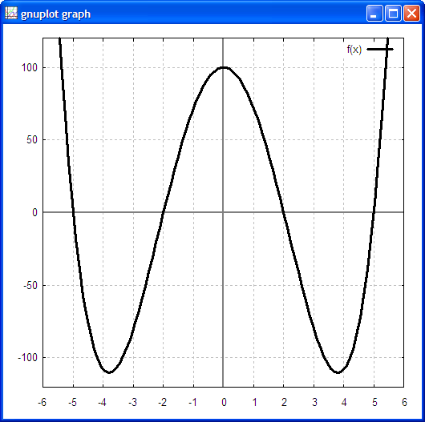
file and version info: t4a.odt 200611161115

1. Find the y-intercept for the fourth degree function:
f(x) = x⁴ − 29x² + 100
y= 100
2. The function f(x) = x⁴ − 29x² + 100
has how many linear factors?
Four.
3. The function f(x) = x⁴ − 29x² + 100
has how many zeros?
Four.
4. Perform the long division:
(x⁴ − 29x² + 100) ÷ (x + 5)
x³ − 5x² − 4x + 20
5. Find all of the zeros for f(x) =x⁴ − 29x² + 100
x = ±2, x = ±5
6. Sketch a graph of y = x⁴ − 29x² + 100 on the blank graph provided.
7. The function seen in the graph on the right has how many zeros based on what you can see in the graph?
Six.
8. The function seen in the graph on the right has at least how many linear factors?
Six.
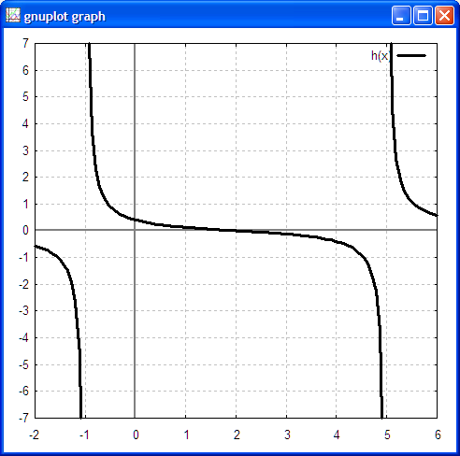
9. What is the minimum possible degree of the function seen on the right?
Six.
10. For
a. Find the y-intercept.
y = 2/5
b. Find the x-intercept(s) [zero(s)]
x = 2
c. Find the vertical asymptote(s)
x = 5, x = −1
d. Find the horizontal asymptote
y = 0
(the horizontal x-axis: deg of denom >
deg of numerator.

