MS 100 PreQuiz 06/05/06 • Name: ____________________________

P1a. Evaluate –x² + – 4 for x = – 4

P1b. Write in simplest form:

P2. Simplify:

P3. Multiply: (x – 5)(x³ + 5x² + x + 10)

P4. Factor as completely as possible: x² – 5x + 6

P5. Simplify:

P7. Plot the following points on the provided graph, and label them with their respective letters:
A. (4, 20) B. (– 2, 7.5) C. (– 3, – 12) D. (1.5, –10)
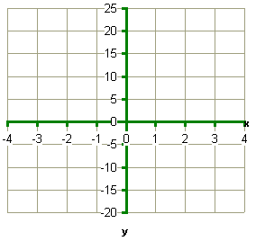
P7. On the same grid, sketch y = 5x – 10

P8. Solve for x: x² + 24x + 143 = 0

