MS 100 College Algebra Spring 2006 Test Six
1. Calculate (expand):
= x² – x – 16.25i²
= x² – x + 16.25

2. For f(x) = x² – x – 15.75 g(x) x + 15.75
Find the composition:
= [ x² – x – 15.75 ] + 15.75
= x² – x

3. All about f(x) = x² – x – 15.75...
2 a. What is the degree of the function f(x) = x² – x – 15.75?
even b. Is f(x) = x² – x – 15.75 an even or odd function?
up c. Does f(x) = x² – x – 15.75 open up or open down?
2 d. What is the maximum number of zeros for f(x) = x² – x – 15.75?
parabola e. What is the name of the shape produced by f(x) = x² – x – 15.75?
–15.75 f. What is the y-intercept for y = x² – x – 15.75?

g. Solve x² – x – 15.75 = 0 by completing the square. Show your work.
x² – x = 15.75
x² – x + 0.25 = 15.75 + 0.25
(x – 0.5)² = 16

x – 0.5 = ±4
x = 0.5 ±4
x = –3.5, x = 4
h. Find the x-intercepts for f(x) = x² – x – 15.75
x = –3.5, x = 4
i. Use the formula to find the vertex (h, k) for
y = x² – x – 15.75
(h , k) = (0.5, –16)
j. Use the formula (h, k+p) where to find the focus for
f(x) = x² – x – 15.75
(0.5, –15.75]
k. Sketch a graph of f(x) = x² – x – 15.75:
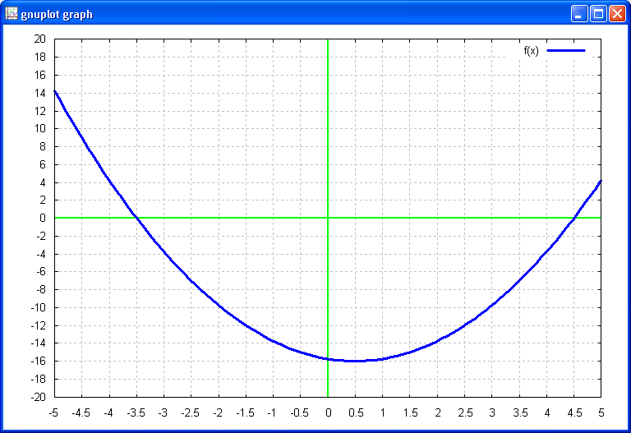
4. Solve by completing the square x² – x + 16.25 = 0. Show your work.
x² – x = –16.25
x² – x + 0.25 = –16.25 + 0.25
(x – 0.5)² = –16

x – 0.5 = ±4i
x = 0.5 ±4i
x = 0.5 + 4i, x = 0.5 – 4i

Factors (not required, only done to show connection to problem one}:

(x – 0.5 – 4i][x – 0.5 + 4i] or

