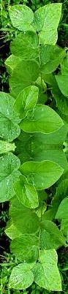
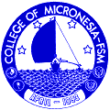
College of Micronesian – FSM
P.O. Box 159
Pohnpei FM 69641

27 April 2016

Receipt for performance of cultural ceremony and for the supplies necessary to that ceremony

For SC/SS 115 Ethnobotany course

Received: $100.00

Received by: ____________________________________

Signature: ____________________________________

Date: ________________

Ritual is the way you carry the presence of the sacred.
Ritual is the spark that must not go out.

