Ipomoea pes-caprae sonsol

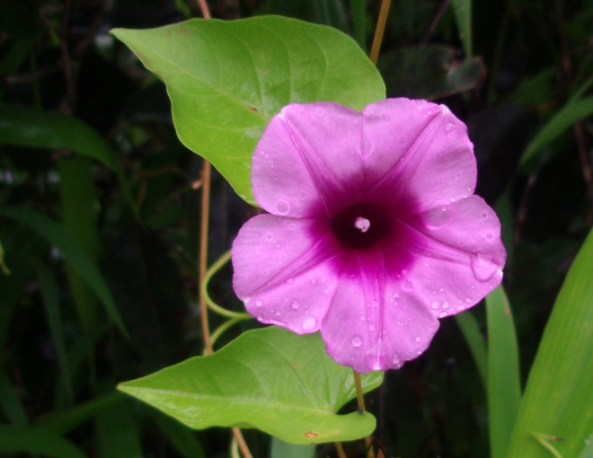

Family: Convulvaceae

Description: Herbaceous vine with brilliant magenta flowers, blossoms in the morning.

Location: Shorelines and fringes of the island.

Uses: To ease the pains of delivery and labor, pound the leaves and drink the juice.

Scientific identifications are tentative.
Spellings of Pohnpeian name are tentative.
Credits: College of Micronesia-FSM Pohnpei and National campuses, Totoa Fetalai-Currie, Bruno Barnabas, Yoster Kemillios, Jackson Phillip, Dana Lee Ling, and the students of SC/SS 115 Ethnobotany.

