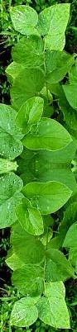
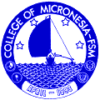
Division of Natural Sciences and Mathematics
College of Micronesia–FSM
P.O. Box 159 Kolonia
Pohnpei FM 96941
Fax: 011-691-320-2479

Tuesday, December 02, 2008

Dear Senator Halbert:

The SC/SS 115 Ethnobotany class wishes to thank-you and your family both for your hospitality and for sharing with the students at the college the culture and traditions of Pohnpei.

The ceremony was most informative and the students both from Pohnpei and the other states of the FSM learned a great deal from the experience. The students have gained a deeper and stronger understanding of the importance and role of tradition in Pohnpei.

Again our sincere thanks,

Ben, Jr Albert
Cantina Albert
Paulino Balagot
Vinton P. Benjamin
Nartha Eliam
Connie Eperiam
Cynthia Fredrick
Stephanie Fredrick
Maycleen Gilmete
Kehlen Halbert
Suannrita Ladore
Rusi Lengsi
Arleen J Nedelec
Santryco Oswalt
Benjamin Raetilmwai
Edmond Samuel
Mauricio Santiago
Vinnesalyn Tafleimal
Kyoko Talley
Mathew Tiegmai
Gloria Yamada
Chersea Yleizah

Dana Lee Ling
Professor
College of Micronesia – FSM

