Hands On 2
Objective(s) : To enhance webpage presentation by presenting text attractively and adding background
color or graphics
Requirements : Output in Exercise 1
If you are not yet done with your exercise yesterday, you have to continue creating the other WebPages. This is necessary for Exercise 3. To give you idea on what to include, you may visit these WebPages:
For course WebPages: www.comfsm.fm/~gmangonon
www.comfsm.fm/~mmmangonon
www.comfsm.fm/~pulmano
For division WebPages: www.comfsm.fm/~gmangonon/mspniweb/index.htm
www.comfsm.fm/~mmmangonon/businessdivision/index.htm
For office WebPage: www.comfsm.fm/~mmmangonon/vpia/index.htm
http://www.comfsm.fm/~gmangonon/icpniweb/instructional1/index.htm

In this exercise, you will be exploring some of the nuts and bolts of text presentation and information layout- the specification of boldface, italics, and other changes that you can make to text.

Select from your flash-drive the folder “Course Webpage Project” and open index.htm.

Underlining, Italicizing, and Other Text Changes
In this exercise, decide on your own which texts need to be written in boldface or in italics.
• The italic formatting tag is <i>, which is paired with </i>.
• The boldface formatting tag is <b>, and its partner is </b>.
Caution: Always follow the opening angle bracket of an HTML formatting tag with the format code immediately; no spaces are allowed.
Ex. <b>Home</b>][<b>Courses</b>][<b>Syllabi</b>][<b>Schedule</b>][<b>Resources</b>][<b>Announcements</b>][<b>Potpourri</b>][<b>About Me</b>] (making the word in-between the tags bold)

<i><b>Walking is the best exercise.</b></i> (making the word in-between the tags italicized)

Save your work and then open the file in IE browser to see the results. Repeat the process for all the files you have created. (Let your browser remain open)

A number of other formatting options are available within Web documents:
• The underline formatting tag is <u>, which is paired with </u>. Ex. <u><i><b>best exercise.</b></i></u>
• The monospace tag is <tt>, which is paired with </tt>. Ex. <tt><u><i><b>best exercise.</b></i></u></tt>
Monospace is so named because each letter in a monospace typeface occupies exactly the same width as every
other letter, even if the letter itself is quite narrow. Monospace type typically looks like the product of a typewriter:
This is an example of a monospace typeface.
• Superscripts are denoted by <sup> and </sup>, subscripts by <sub> and </sub>.
Ex. H<sub>2</sub>O<sup>2</sup> - for H₂O²

If you feel that you need these text formatting tools in your works, go ahead and use them.

Specifying Font Sizes, Colors, and Faces
HTML font sizes range from size 1 to size 7, with 1 being the smallest and 7 the largest (the opposite of the numbering system for header tags, where Header 1 is the largest and Header 6 the smallest.)

To change the size of a passage of text, you can use this formatting: <font size=”7”>some important text</font>
Combined with other formatting: <i><b><font size="7">some important text</font></b></i>

Note: The closing tag </font> doesn’t need to include the attributes of the tip opening tag: You don’t have to use </font size=”7”> to end the larger text. You can specify font sizes absolutely, as in the previous example, or you can use relative size changes. Here’s the HTML to make a particular word one font size larger than the text surrounding it:

This is a <font size=”+1”>very</font> important issue to us.
The default font size in Web browsers is size=”3”. Relative changes can’t go below size=”1” or above size=”7”, so if you have a default size of 3 and add 10 to it, with a tag like font size=”+10”, it’ll be identical in function to font size=”7” (or font size=”+4”).

Try changing your font sizes now to sizes you feel necessary. Always save your work and refresh the browser to see the changes you have just created.

You can specify color for a range of text in a similar manner by using a different font attribute. To display a passage of text in blue, for example, you can use <font color=”BLUE”>I’m blue</font>

You can choose from a wide variety of colors that can be specified by name, and you can have even finer resolution of color control by using RGB (red-green-blue) hexadecimal values. For basic colors, however, you can work without worrying about the RGB values and, instead, just specify them by name.

Popular Colors Available by Name:
Aqua Black Blue Fuchsia Gray Green Lime Maroon Navy Olive Purple Red Silver Teal White Yellow

Common Colors as Hex RGB Values
Hex Color Value Common Color Name Hex Color Value Common Color Name
00 00 00 Black 00 FF 00 Green
FF FF FF White FF FF 00 Yellow
FF 00 00 Red 00 00 FF Blue
FF 00 FF Purple 00 FF FF Aqua

The markup language has a nice feature that enables you to specify several attributes within one HTML tag, thereby achieving multiple effects. If you want big red text, for example, you do it with this code:
<font size=”6” color=”red”>Clifford</font>
It doesn’t matter in what order you specify the name=”value” pairs. So to the browser
<font color=”red” size=”6”> is identical to <font size=”6” color=”red”>

However, the attributes must be tucked within the <> pair, so <font><size=”6”><color=”red”> won’t work, nor will <font size=”6”><color=”red”>. Both are common errors for neophyte HTML coders, however, so be alert that this doesn’t creep into your own markup work.

Ex. of combinations: <i><b><font size="4" color=lime>some important text</font></b></i>

Try editing now your previous tags combining font sizes and colors. Don’t forget to always save your work then refresh your browser so you’ll know if your getting what you desire your fonts to be.

The third possible attribute for the font tag is the typeface specifier face (e.g. Times Roman, Arial, Verdana, Helvetica, etc.). Specify typefaces with the face attribute to the font tag.
Ex. <font size=”4” color=”blue” face=”Arial Narrow”>Skinny Text</font>
This means that the phrase “Skinny Text” is displayed with an Arial Narrow typeface, size 4 and color blue.
Edit your tags again to include the typeface of the fonts.
Ex. of combinations: <i><b><font size="4" color=lime face="Arial">some important text</font></b></i>

One final tag and you have an example that demonstrates all these modifications: To change the default size of all text on a page, you use <font size=”4”> or a similar tag at the very top of the document. There’s another way to change the color of text on your page, but it applies to all text tip on the page at once: Add the text attribute to the body tag. For example, to have all text blue, add the following line of code: <body text=”blue”>

You can make your text fun and interesting by using the font tag attributes to specify a variety of Colors, typefaces and sizes.

Background Colors and Graphics

To add a background color or background graphic, you add an attribute to the <body> tag. The <body> tag should already be an integral part of your existing Web pages. After you start modifying the <body> tag, it is absolutely crucial that you place it in the correct spot on your pages. Remember, all Web pages should start with an <html> tag, followed by <head> and <title> tags. A </head> tag ends the header section, and immediately following, you should insert the <body> tag. If you have the <body> tag in the wrong place—particularly if you place it subsequent to any specification of information to appear on the Web page itself (such as an <h1> tag)—your browser ignores any background changes.

You specify background colors with bgcolor=”colorname” or bgcolor=”#rgb-value”, and you specify a background graphic with background=”filename”

Ex.

For background graphic: <body background=backgrnd.gif>

Viewing your Final Page

If you are done will all the required enhancements, view your home page using the browser. Check all links by clicking on each one of them.

Sample code 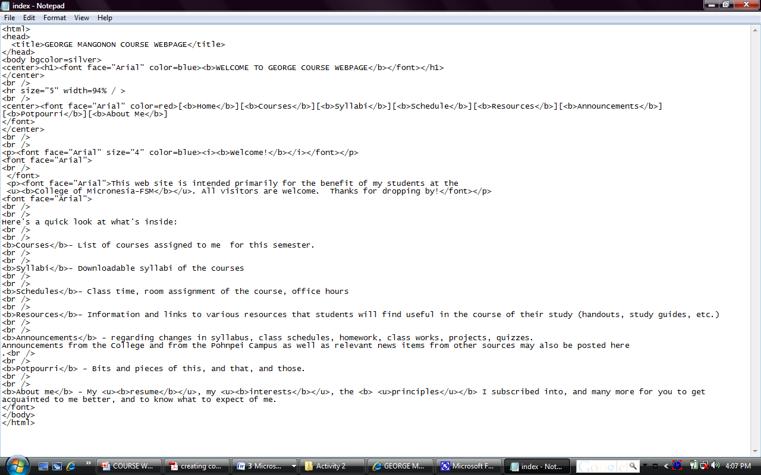

Output:



Save all your html files and exit both Notepad application and Internet Explorer browser

Hands-on exercises tomorrow would involve adding hyperlinks to your Web Pages.

