Import – Artificial Flowers Business Plan

- Executive Summary

Fantastic Florals, Inc. (FFI) imports exclusively handmade flowers by artisans from Indonesia. The firm's main office is in Anytown, Oregon, and has a customs house broker in Seattle, Washington to deal with related matters.
FFI quality products are unique and exclusive, and its target consumers are women with upper-middle to upper-end incomes. FFI's competitive edge is that the products are 100% handmade, unlike competitor's products. By this fact, the firm hopes to attract people that value the artistry of producing silk flowers. Since FFI products are mostly silk flowers and silk hair accessories, it considers itself to be in the retail gift market, although some consumers purchase the product for themselves.
For the starting year 1995, the company plans to attract manufacturer reps and retailers to distribute the products by attending the Silk '94 trade show in Chicago, Illinois. This trade show is where suppliers of silk flowers and other silk products and buyers meet and arrange deals to sell the product. FFI projected sales are approximately $1.1 million by the end of the first year of operation. Also during this year, FFI plans to open an exclusive gift shop for our product in Anytown at the Third Street Public Market, leasing for five years.
For the following year, the company plans to expand to direct mail catalog sales by being in an established catalog, with a similar target market. FFI projects sales of $1.5 million in 1996. During the third year, FFI plans to do both selling through suppliers, catalogs, and the exclusive gift store in Anytown, projecting sales to be nearly $2 million.
The FFI family will expand in 1997 by adding 10 different kinds of flowers and flower arrangements. Maintaining an average gross margin of 25 percent is very realistic. The projected rate of annual growth in sales is 25 percent.
Highlights
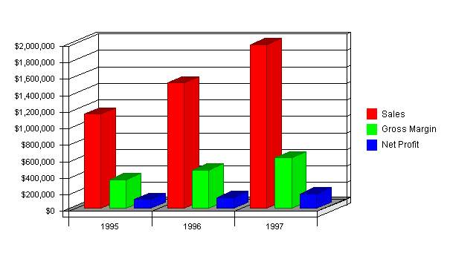
1.1 Objectives
- Achieve 1995 sales of $1.1 million.
- Open gift shop in Anytown at Third Street Public Market with five-year lease.
- For 1996, expand into direct mail catalogs.
- Maintain gross margin of 25 percent.
- Establish annual growth rate of 25 percent.
- Expand product family by adding 10 different kinds of flowers and flower arrangements in 1997.
1.2 Mission
FFI's mission is to become a recognized importer of artisan quality silk gift items in the United States. The company guarantees 100 percent customer satisfaction and values friendly service.
FFI's purpose is to increase customer appreciation of handmade silk flowers and other silk products and to provide customers with beautiful unique artistic decorations.
1.3 Keys to Success
Keys to success for Fantastics Florals Inc. are:
- Product quality.
- Customer service.
- Access to manufacturers and distribution channels.
- Controlling fixed and variable costs during first two years.

Company Summary
2.0 Company Summary
Fantastic Florals, Inc. imports silk flowers and other silk accessories products from artisans in Indonesia and distributes the products to customers in the United States. The customers are retail stores and wholesalers who want imported silk flowers and accessories products, targeting women in middle-upper to upper-end income as the end user of the products.
2.1 Company Ownership
Fantastic Florals, Inc. is a privately held Anytown corporation. Suzy Rosemadder, FFI's founder, is the majority owner. Several members of the board of directors also hold minority stock positions.
2.2 Start-up Summary
Start-up costs are approximated at $75,000, which primarily consists of product costs and expenses associated with establishing a marketing program and opening up FFI's first distribution center.
Start-up
Start-up
Requirements
Start-up Expenses
Legal | $1,000
Insurance | $600
Rent | $1,300
Other | $200
Total Start-up Expenses | $3,100
Start-up Assets Needed
Cash Balance on Starting Date | $70,000
Start-up Inventory | $0
Other Current Assets | $0
Total Current Assets | $70,000
Long-term Assets | $0
Total Assets | $70,000
Total Requirements | $73,100
Funding
Investment
Investor 1 | $35,000
Investor 2 | $0
Other | $0
Total Investment | $35,000
Current Liabilities
Accounts Payable | $3,100
Current Borrowing | $35,000
Other Current Liabilities | $0
Current Liabilities | $38,100
Long-term Liabilities | $0
Total Liabilities | $38,100
Loss at Start-up | ($3,100)
Total Capital | $31,900
Total Capital and Liabilities | $70,000
Start-up
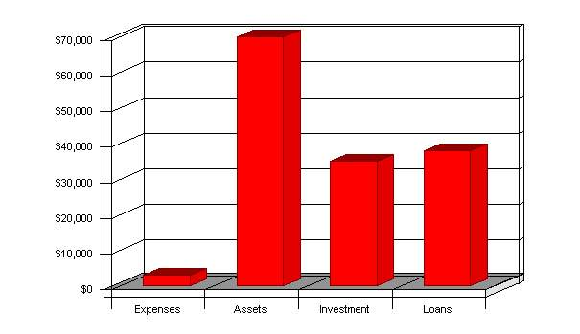
2.3 Company Locations and Facilities
FFI's headquarters are located in Anytown at the founder's home, 1234 Main Street, Anytown, OR 97440. It will also have a 600-square foot retail store at the Third Street Public Market, which will serve as both an outlet and test market.

Products
3.0 Products
FFI imports silk flowers and other silk accessories. These products provide consumers with a wide variety of product lines and allows for individual customization of orders.
3.1 Product Description
Fantastic Florals, Inc. has a variety of silk flowers and products from which to choose. During the first two years, the product line will include:
- Tulips and roses.
- Two kinds of flower arrangements.
- Silk scarf and silk hair accessories.
- Seasonal bouquets.
3.2 Competitive Comparison
Fantastic Florals, Inc. products contain these features that distinguish them from those produced by competitors:
- FFI products are 100 percent handmade by Indonesian artisans and are then imported into the United States, which will be emphasized in all marketing efforts.
- The quality of the silk flowers is obvious, even to the untrained eye. There is no use of plastic stems, which makes FFI products look more realistic.
- FFI silk hair accessories are unique, and no similar product is available in the domestic market. These products will be protected by owning a patent. The product features beautiful embroidery on its edge, which will cost much more if it were to be produced in the United States.
3.3 Sales Literature
Copies of FFI products, more specifically bouquets and other arrangements are included. Upon production of advertisements and brochures, these will be added.
3.4 Sourcing
FFI imports products from artisans in Indonesia and then hires brokers in Seattle to take care of the legal requirements and paperwork. Currently, there are no significant obstacles in importing the products into the United States. According to the U.S. Customs Office in Seattle, there are no quotas for artificial products imported from Indonesia. FFI will benefit from the duty-free treatment under the new GSP rules.
3.5 Technology
Some FFI products are protected by patents, although the majority of products and services are not dependent on patentable inventions nor process technology.
3.6 Future Products
Fantastic Florals, Inc. plans to introduce ten new kinds of flowers and silk products every year for the first four years, with aggressive advertising at the beginning of each year that introduces these new flowers.
After establishing a firm reputation, FFI plans to import products other that silk products, but all will still be related to flowers. These will be produced by Indonesian artisans in various cities in the original region, all managed by the same artist. The products will include silk jewelry boxes, mirrors, and china, all with hand-painted flowers.

Market Analysis Summary
4.0 Market Analysis Summary
Currently, the market for permanent floral products is rapidly expanding. According to 1993 statistics, the value of permanent floral products for the 1992 fiscal year was over $2.2 billion, and it still continues to grow.
The gift industry is also growing, as households headed by 45- to 54-year-olds are the biggest gift purchasers.
4.1 Market Segmentation
Since Fantastic Florals, Inc. only deals with a few, select products, segmentation is minimal. Two segments currently exist:
- Gift purchasers-mostly women over 30 with a relatively large amount of discretionary income.
- Floral collectors-same target as above, but with higher standards of quality.
Market Analysis (Pie)
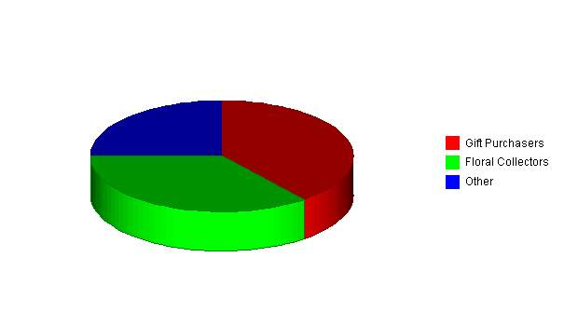
Market Analysis
Market Analysis
Potential Customers | Growth | 1995 | 1996 | 1997 | 1998 | 1999 | CAGR
Gift Purchasers | 6% | 275,000 | 291,500 | 308,990 | 327,529 | 347,181 | 6.00%
Floral Collectors | 4% | 250,000 | 260,000 | 270,400 | 281,216 | 292,465 | 4.00%
Other | 3% | 175,000 | 180,250 | 185,658 | 191,228 | 196,965 | 3.00%
Total | 4.56% | 700,000 | 731,750 | 765,048 | 799,973 | 836,611 | 4.56%
4.2 Industry Analysis
There are two industries for Fantastic Florals, Inc.: the gift market industry and the silk flower and accessories industry.
In 1991, the average American household gave 5.8 percent of its total spending to gifts, a 0.3 percent increase from 1988. Households headed by 45- to 54-year-olds are the biggest gift-givers. These consumers spend an average of $1,450 on gifts, which is 62 percent more than the average household. In addition, married couples without children are the most generous gift-givers. These households spend 48 percent more than average on gifts. Households with incomes of over $65,000 spent 135 percent more than average on gifts, while they also account for 58 percent of the glassware gift market and 62 percent of the plant and flower gift market. By the year 2000, it is estimated that households headed by 35- to 54-year-olds will account for 63 percent of the gift market.
In the silk flowers and accessories industry, flowers alone accumulated sales over $1.95 billion in 1992. This category still continues to grow.
Considering the information and analysis of both industries, FFI believes that its products have the opportunity to be successful in the market. The growing gift industry and silk flower and accessories industry imply that there is a growing demand for these products. Because there is no similar product currently available in the U.S. market, FFI has a huge opportunity in the silk accessory industry.
4.2.1 Industry Participants
There are currently no direct competitors in the silk hair accessories market, and the silk flowers industry is very unconcentrated. Few wholesalers distribute directly to the consuming public, and the majority of retail stores only offer a minimal selection with varying quality.
Both industries, however, are predicted to develop further, while the gift industry also continues to grow. As the markets evolve, the key issue will be relations with suppliers. As there are few suppliers of silk flowers and accessories, competition is likely to increase substantially.
4.2.2 Distribution Patterns
Distribution channels are currently relatively simple. There is one artist in Indonesia who provides all products for FFI. The products are shipped directly to FFI facilities, which are then sold to consumers. There are no significant obstacles to importing these products, and there are no import quotas.
4.2.3 Competition and Buying Patterns
According to the information from Silk '94, the wholesale buyers of silk flowers and accessories are:
- 53 percent - Floral Wholesalers.
- 19 percent - Craft Chain Stores, Floral Chain Stores, Gift Chain Stores, Variety Chain Stores, Fabric Centers.
- 19 percent - Manufacturers/Assemblers.
- 9 percent - Home Centers, Membership Clubs, Nursery and Garden Centers, Catalog/Mail Order, etc.
4.2.4 Main Competitors
Fantastic Florals, Inc. current competitors in the surrounding area are:
- Flower markets.
- Floral wholesalers.
- Craft stores.
- Gift shops.

Strategy and Implementation Summary
5.0 Strategy and Implementation Summary
FFI focuses on providing high-quality products to consumers with outstanding service. Customization of orders and specialization of services will create a competitive advantage.
FFI is developing the organization by beginning with few employees to reduce costs. All current employees are very motivated, resulting in a positive and strong company culture. This culture will carry over to all new trainees, which is a prime objective for the expansion of FFI.
The first year of service will be the most important, as FFI plans to establish strong relations with both suppliers and buyers. These relationships will help FFI to grow and evolve in this industry.
5.1 Marketing Strategy
- FFI is focusing on silk flowers and accessories, targeting women with upper-end income as the end customers, and targeting sales reps that distribute to exclusive gift retail stores and mail-order catalog companies.
- FFI plans to be an exhibitor at Silk '95, having already collected all the necessary information at Silk '94. This trade show is the largest international silk flower and accessories exhibition attended by multiple buyers including, but not limited to, catalog/mail-order, floral wholesalers, chain stores, craft stores and wholesalers, visual display companies, etc. This will be a good opportunity to start and get exposure to FFI's product. FFI plans to attract the right sales rep and mail-order company for its products through this trade show, which is realistic since Silk '95 is the biggest and most reputable permanent and silk accessories trade show in the United States.
- For the first year, FFI will both lease a space for a retail store at the Third Street Public Market and supply its products to buyers that FFI attains though Silk '95.
- FFI will also send some samples to "Blossom" catalog, who does mail orders for silk flowers and other silk accessories. The purpose of this is to reach more customers while doing only minimal research.
5.1.1 Pricing Strategy
FFI sets standard prices for each product line. These prices are not expected to experience significant change over the next three years.
- Tulips and Roses - $2.25
- Arranged Flower 1 - $18.99
- Arranged Flower 2 - $39.99
- Silk Scarf - $15.99
- Other hair accessories - $9.99
- Other/Seasonal bouquet - $59.99
These prices exhibit quality products at reasonable costs to consumers.
5.1.2 Promotion Strategy
The goal of FFI is to promote its products as fine collectibles, either for the collector or the gift-buyer. This will be done through in-store promotions, direct-mail advertisements, appearances in related catalogs, and publicity events.
5.2 Sales Strategy
Products will be distributed through the retail store in Anytown at Third Street Market or by pre-orders until FFI is able to further expand. Sales is one area that needs to be developed in order to better serve the consumer and meet objectives.
5.2.1 Sales Forecast
As indicated in the table, sales are forecasted to remain relatively constant throughout 1995, with growth predicted in both 1996 and 1997. Sales, however, will tend to fluctuate depending on the month and the season.
Sales Monthly
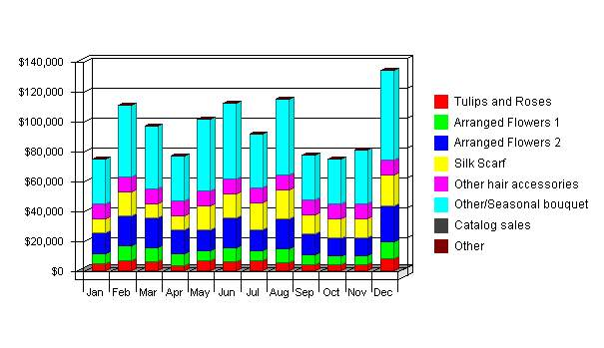
Sales Forecast
Sales Forecast
Unit Sales | 1995 | 1996 | 1997
Tulips and Roses | 28,300 | 35,165 | 45,714
Arranged Flowers 1 | 5,000 | 6,501 | 8,451
Arranged Flowers 2 | 5,000 | 6,500 | 8,450
Silk Scarf | 10,800 | 13,910 | 18,083
Other hair accessories | 12,000 | 15,600 | 20,280
Other/Seasonal bouquet | 8,200 | 10,660 | 13,858
Catalog sales | 0 | 20,000 | 30,000
Other | 0 | 0 | 0
Total Unit Sales | 69,300 | 108,336 | 144,836
Unit Prices | 1995 | 1996 | 1997
Tulips and Roses | $2.25 | $2.00 | $2.00
Arranged Flowers 1 | $18.99 | $19.00 | $19.00
Arranged Flowers 2 | $39.99 | $40.00 | $40.00
Silk Scarf | $15.99 | $16.00 | $16.00
Other hair accessories | $9.99 | $10.00 | $10.00
Other/Seasonal bouquet | $59.99 | $60.00 | $60.00
Catalog sales | $0.00 | $2.25 | $2.25
Other | $0.00 | $0.00 | $0.00
Sales
Tulips and Roses | $63,675 | $70,330 | $91,428
Arranged Flowers 1 | $94,950 | $123,519 | $160,569
Arranged Flowers 2 | $199,950 | $260,000 | $338,000
Silk Scarf | $172,692 | $222,560 | $289,328
Other hair accessories | $119,880 | $156,000 | $202,800
Other/Seasonal bouquet | $491,918 | $639,600 | $831,480
Catalog sales | $0 | $45,000 | $67,500
Other | $0 | $0 | $0
Total Sales | $1,143,065 | $1,517,009 | $1,981,105
Direct Unit Costs | 1995 | 1996 | 1997
Tulips and Roses | $1.50 | $1.50 | $1.50
Arranged Flowers 1 | $11.99 | $12.00 | $12.00
Arranged Flowers 2 | $27.99 | $28.00 | $28.00
Silk Scarf | $8.50 | $8.50 | $8.50
Other hair accessories | $6.50 | $6.50 | $6.50
Other/Seasonal bouquet | $42.00 | $42.00 | $42.00
Catalog sales | $0.00 | $1.49 | $1.49
Other | $0.00 | $0.00 | $0.00
Direct Cost of Sales | 1995 | 1996 | 1997
Tulips and Roses | $42,450 | $52,748 | $68,571
Arranged Flowers 1 | $59,950 | $78,012 | $101,412
Arranged Flowers 2 | $139,950 | $182,000 | $236,600
Silk Scarf | $91,800 | $118,235 | $153,706
Other hair accessories | $78,000 | $101,400 | $131,820
Other/Seasonal bouquet | $344,400 | $447,720 | $582,036
Catalog sales | $0 | $29,800 | $44,700
Other | $0 | $0 | $0
Subtotal Direct Cost of Sales | $756,550 | $1,009,915 | $1,318,845
5.2.2 Sales Programs
- Floral wholesalers: Develop awareness about the quality of FFI's products in order to create demand within the first two months. For the next year, provide incentives and price-promotions to encourage wholesalers to purchase FFI products.
- Retail Stores: Offer low-priced products in exchange for significant shelf space and access to consumers. By the end of the first year, have FFI products distributed in selected stores with minimal constraints on price and location.
- Manufacturers/Assemblers: Provide FFI products at a reduced rate corresponding to volume of purchase.
5.2.3 Sales Goals
- End of 1995 - Sales of $1.1 million.
- July 1995 - Open exclusive gift shop at Third Street Market in Anytown.
- 1996 - Sales of $1.5 million.
- July 1996 - Expand distribution into catalog/direct mail.
- 1997 - Sales of $2 million.

Management Summary
6.0 Management Summary
Fantastic Florals, Inc. will start with three qualified and experienced employees. An increase to six employees will likely be needed in three to five years. FFI will continue to have a customs-house broker in Seattle to take care of the import-related matters and sales representatives who are compensated based on commission.
6.1 Organizational Structure
Fantastic Florals, Inc. will be a Subchapter-S corporation. Legal matters and written agreements are being handled by an FFI consultant lawyer.
The company is organized into three main functional areas:
- Sales and marketing.
- Finance and administration.
- Communication.
6.2 Management Team
- Suzy Rosemadder: President and founder. Graduated from the University of North Carolina (major: management). Originally from Indonesia and has worked for a silk flower company there for five years. Familiar with the Indonesian government and key people there.
- Angela Stalks: On Board of Directors. Previously manager of an exclusive gift shop in Dallas, Texas for ten years. MBA in Finance from University of Minnesota.
- Steven Gardener: On Board of Directors. Will be in charge of marketing and sales. Graduated from Cornell University with B.S. degree in marketing and public relations.
6.3 Management Team Gaps
Each of the three employees is responsible for managing his or her area of expertise. The problems with having only one individual in charge of a department are as follows:
- Lack of understanding of other departments.
- Minimal management experience.
- Sole control over all operations.
6.4 Personnel Plan
The personnel plan indicates one employee for each department:
- Production/Fulfillment.
- Sales and Marketing.
- Administration.
Beginning in 1996, there will be two employees in both Sales and Marketing and Administration.
Personnel
Personnel Plan
 | 1995 | 1996 | 1997
Production | $14,400 | $16,000 | $18,000
Sales and Marketing | $14,400 | $32,000 | $54,000
Administration | $14,400 | $32,000 | $36,000
Other | $0 | $0 | $0
Other | $0 | $0 | $0
Total People | 0 | 0 | 0
Total Payroll | $43,200 | $80,000 | $108,000

Financial Plan
7.0 Financial Plan
- Fantastic Florals, Inc. projects the gross margin to be at approximately 25 percent. Sales projection for 1995 is at $1.1 million, increasing to $1.5 million in 1996 and $2 million in 1997.
- FFI is looking for an investor who would invest $75,000 for 20 percent of the company.
- Cash-flow analysis, balance sheet, business ratio, break-even analysis, and other financial details are shown in the appendix.
7.1 Important Assumptions
General assumptions in FFI's financial plan indicate the assumption of a stable economy without any major recessions or booms in both the U.S. and Indonesian economies.
General Assumptions
General Assumptions
 | 1995 | 1996 | 1997
Plan Month | 1 | 2 | 3
Current Interest Rate | 15.00% | 15.00% | 15.00%
Long-term Interest Rate | 10.00% | 10.00% | 10.00%
Tax Rate | 39.17% | 40.00% | 39.17%
Sales on Credit % | 50.00% | 50.00% | 50.00%
Other | 0 | 0 | 0
7.2 Key Financial Indicators
Key financial indicators for Fantastic Florals, Inc. include:
- Constant gross margins.
- Sales on credit.
- Net worth.
- Return on equity.
Benchmarks
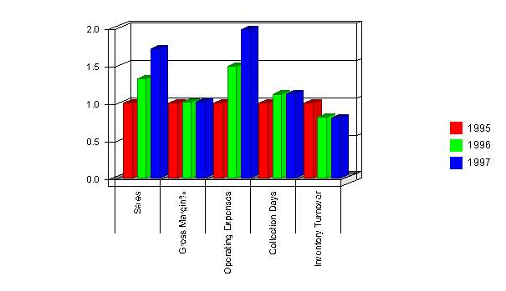
7.3 Break-even Analysis
FFI's break-even analysis indicates that the firm has a strong balance of costs and sales. The break-even point is at just over 1200 units and close to $21,000.
Break-even Analysis
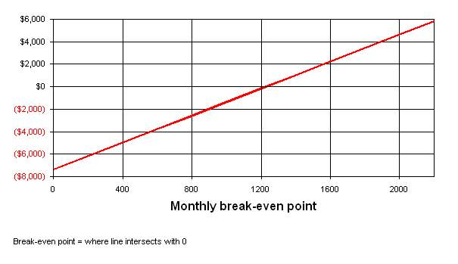
Break-even Analysis
Break-even Analysis:
Monthly Units Break-even | 1,228
Monthly Revenue Break-even | $20,870
Assumptions:
Average Per-Unit Revenue | $17.00
Average Per-Unit Variable Cost | $11.00
Estimated Monthly Fixed Cost | $7,366
7.4 Projected Profit and Loss
Fantastic Florals, Inc. projects profits for every month of 1995 and on into both 1996 and 1997, in addition to positive growth margins for the same time periods.
Profit and Loss
Pro Forma Profit and Loss
 | 1995 | 1996 | 1997
Sales | $1,143,065 | $1,517,009 | $1,981,105
Direct Costs of Goods | $756,550 | $1,009,915 | $1,318,845
Shipping etc. | $40,235 | $44,260 | $48,688
 | ------------ | ------------ | ------------
Cost of Goods Sold | $796,785 | $1,054,175 | $1,367,533
Gross Margin | $346,280 | $462,835 | $613,573
Gross Margin % | 30.29% | 30.51% | 30.97%
Expenses:
Payroll | $43,200 | $80,000 | $108,000
Sales and Marketing and Other Expenses | $84,455 | $118,860 | $162,302
Depreciation | $2,400 | $2,640 | $2,904
Leased Equipment | $0 | $0 | $0
Utilities | $2,400 | $2,640 | $2,904
Insurance | $7,200 | $7,920 | $8,712
Rent | $15,600 | $17,160 | $18,876
Payroll Taxes | $7,776 | $14,400 | $19,440
Other | $0 | $0 | $0
 | ------------ | ------------ | ------------
Total Operating Expenses | $163,031 | $243,620 | $323,138
Profit Before Interest and Taxes | $183,249 | $219,215 | $290,435
Interest Expense | $7,292 | $2,250 | $625
Taxes Incurred | $69,503 | $86,786 | $113,509
Net Profit | $106,455 | $130,179 | $176,301
Net Profit/Sales | 9.31% | 8.58% | 8.90%
7.5 Projected Cash Flow
FFI's cash balance is expected to increase each year, providing the necessary capital for expansion into different product lines and distribution channels.
Cash
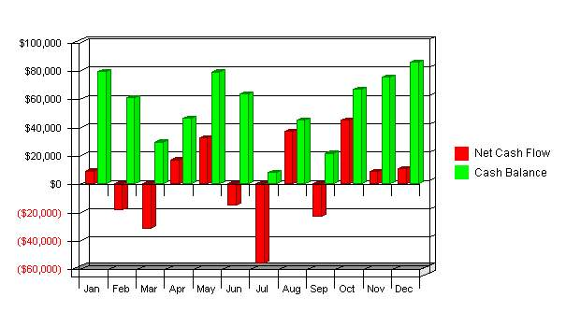
Cash Flow
Pro Forma Cash Flow
 | 1995 | 1996 | 1997
Cash Received
Cash from Operations:
Cash Sales | $571,533 | $758,505 | $990,553
Cash from Receivables | $485,730 | $730,435 | $955,716
Subtotal Cash from Operations | $1,057,262 | $1,488,939 | $1,946,268
Additional Cash Received
Sales Tax, VAT, HST/GST Received | $0 | $0 | $0
New Current Borrowing | $48,889 | $0 | $0
New Other Liabilities (interest-free) | $0 | $0 | $0
New Long-term Liabilities | $0 | $0 | $0
Sales of Other Current Assets | $0 | $0 | $0
Sales of Long-term Assets | $0 | $0 | $0
New Investment Received | $0 | $0 | $0
Subtotal Cash Received | $1,106,151 | $1,488,939 | $1,946,268
Expenditures | 1995 | 1996 | 1997
Expenditures from Operations:
Cash Spending | $134,076 | $160,127 | $207,751
Payment of Accounts Payable | $894,116 | $1,241,016 | $1,597,987
Subtotal Spent on Operations | $1,028,192 | $1,401,143 | $1,805,738
Additional Cash Spent
Sales Tax, VAT, HST/GST Paid Out | $0 | $0 | $0
Principal Repayment of Current Borrowing | $62,221 | $13,332 | $8,336
Other Liabilities Principal Repayment | $0 | $0 | $0
Long-term Liabilities Principal Repayment | $0 | $0 | $0
Purchase Other Current Assets | $0 | $0 | $0
Purchase Long-term Assets | $0 | $0 | $0
Dividends | $0 | $0 | $0
Subtotal Cash Spent | $1,090,413 | $1,414,475 | $1,814,074
Net Cash Flow | $15,738 | $74,464 | $132,194
Cash Balance | $85,738 | $160,203 | $292,396
7.6 Projected Balance Sheet
The balance sheet indicates a positive and ever-increasing net worth for FFI, expected to reach close to $440,000 by 1997.
Balance Sheet
Pro Forma Balance Sheet
Assets
Current Assets | 1995 | 1996 | 1997
Cash | $85,738 | $160,203 | $292,396
Accounts Receivable | $85,803 | $113,873 | $148,710
Inventory | $133,182 | $177,784 | $232,168
Other Current Assets | $0 | $0 | $0
Total Current Assets | $304,723 | $451,859 | $673,273
Long-term Assets
Long-term Assets | $0 | $0 | $0
Accumulated Depreciation | $2,400 | $5,040 | $7,944
Total Long-term Assets | ($2,400) | ($5,040) | ($7,944)
Total Assets | $302,323 | $446,819 | $665,329
Liabilities and Capital
Current Liabilities | 1995 | 1996 | 1997
Accounts Payable | $142,300 | $169,950 | $220,496
Current Borrowing | $21,668 | $8,336 | $0
Other Current Liabilities | $0 | $0 | $0
Subtotal Current Liabilities | $163,968 | $178,286 | $220,496
Long-term Liabilities | $0 | $0 | $0
Total Liabilities | $163,968 | $178,286 | $220,496
Paid-in Capital | $35,000 | $35,000 | $35,000
Retained Earnings | ($3,100) | $103,355 | $233,533
Earnings | $106,455 | $130,179 | $176,301
Total Capital | $138,355 | $268,533 | $444,834
Total Liabilities and Capital | $302,323 | $446,819 | $665,329
Net Worth | $138,355 | $268,533 | $444,834
7.7 Business Ratios
The ratios illustrated in the table indicate strong, consistent growth. Business ratios for the years of this plan are shown below. Industry profile ratios based on the Standard Industrial Classification (SIC) code 5193, Flowers and Florist's Supplies, are shown for comparison.
Ratios
Ratio Analysis
 | 1995 | 1996 | 1997 | Industry Profile
Sales Growth | 0.00% | 32.71% | 30.59% | -8.50%
Percent of Total Assets
Accounts Receivable | 28.38% | 25.49% | 22.35% | 6.70%
Inventory | 44.05% | 39.79% | 34.90% | 10.40%
Other Current Assets | 0.00% | 0.00% | 0.00% | 26.40%
Total Current Assets | 100.79% | 101.13% | 101.19% | 43.50%
Long-term Assets | -0.79% | -1.13% | -1.19% | 56.50%
Total Assets | 100.00% | 100.00% | 100.00% | 100.00%
Current Liabilities | 54.24% | 39.90% | 33.14% | 19.50%
Long-term Liabilities | 0.00% | 0.00% | 0.00% | 21.40%
Total Liabilities | 54.24% | 39.90% | 33.14% | 40.90%
Net Worth | 45.76% | 60.10% | 66.86% | 59.10%
Percent of Sales
Sales | 100.00% | 100.00% | 100.00% | 100.00%
Gross Margin | 30.29% | 30.51% | 30.97% | 50.80%
Selling, General & Administrative Expenses | 21.06% | 21.93% | 22.19% | 34.40%
Advertising Expenses | 1.05% | 0.89% | 0.76% | 0.20%
Profit Before Interest and Taxes | 16.03% | 14.45% | 14.66% | 1.50%
Main Ratios
Current | 1.86 | 2.53 | 3.05 | 2.09
Quick | 1.05 | 1.54 | 2.00 | 1.03
Total Debt to Total Assets | 54.24% | 39.90% | 33.14% | 40.90%
Pre-tax Return on Net Worth | 127.18% | 80.80% | 65.15% | 1.10%
Pre-tax Return on Assets | 58.20% | 48.56% | 43.56% | 1.90%
Additional Ratios | 1995 | 1996 | 1997
Net Profit Margin | 9.31% | 8.58% | 8.90% | n.a
Return on Equity | 76.94% | 48.48% | 39.63% | n.a
Activity Ratios
Accounts Receivable Turnover | 6.66 | 6.66 | 6.66 | n.a
Collection Days | 43 | 48 | 48 | n.a
Inventory Turnover | 8.00 | 6.50 | 6.43 | n.a
Accounts Payable Turnover | 7.26 | 7.46 | 7.48 | n.a
Payment Days | 26 | 45 | 43 | n.a
Total Asset Turnover | 3.78 | 3.40 | 2.98 | n.a
Debt Ratios
Debt to Net Worth | 1.19 | 0.66 | 0.50 | n.a
Current Liab. to Liab. | 1.00 | 1.00 | 1.00 | n.a
Liquidity Ratios
Net Working Capital | $140,755 | $273,573 | $452,778 | n.a
Interest Coverage | 25.13 | 97.42 | 464.55 | n.a
Additional Ratios
Assets to Sales | 0.26 | 0.29 | 0.34 | n.a
Current Debt/Total Assets | 54% | 40% | 33% | n.a
Acid Test | 0.52 | 0.90 | 1.33 | n.a
Sales/Net Worth | 8.26 | 5.65 | 4.45 | n.a
Dividend Payout | 0.00 | 0.00 | 0.00 | n.a

