12 1. Add: (6 + 2i) + (6 − 2i)
4i 2. Subtract: (6 + 2i) − (6 − 2i)
40 3. Multiply: (6 + 2i) (6 − 2i)
2x − 12 4. Add: (x − 6 + 2i) + (x − 6 − 2i)
y = x² − 12x + 40 5. Multiply: (x − 6 + 2i)(x − 6 − 2i)

For each of the following three problems:
a. Find the y-intercept (where x = 0)
b. Find the x-intercepts whether real or imaginary (roots, where y = 0)
c. Find the x-value for the axis symmetry
d. Find the coordinates of the vertex
e. Sketch number six and seven on the graph on the back. Do not sketch number eight.
6. y = x² − 12x + 32
a. (0,32) b. (4,0) (8,0) c. axis of symm x = 6 d. vertex (6,−4)
7. y = −x² + 12x − 40
a. (0,−40) b. (6−2i,0) (6+2i,0) c. axis of symm x = 6 d. vertex (6,−4)
8.
a. (0,−8) b. (6−6i,0) (6+6i,0) c. axis of symm x = 6 d. vertex (6,−4)
9. The following graph has the form y = x² + bx + c. Determine b and c. That is, use the graph to find the equation of the curve, the lead coefficient on the squared term being equal to one. x = −7, x = 6. x+7=0, x−6=0. (x+7)(x−6)=0. x² + x − 42=0: y = x² + x − 42
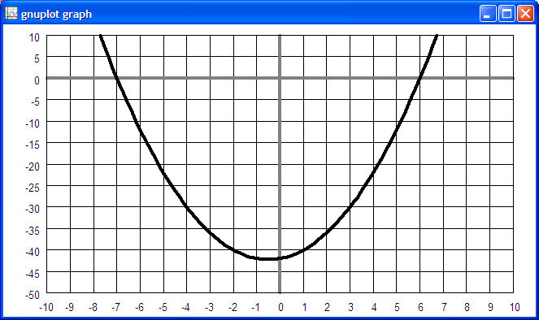

10. Solve for x: 6x + 78 ≥ 468
x ≥ 65

11. Solve for x: 6x + 78 ≠ 468
x ≠ 65

12. Solve for x: −6x − 78 ≥ 468
x ≤ −91

