Arc of a Ball

Today we are going to try to measure a live parabola. Live parabolas move quickly and are hard to capture mathematically. As an additional complication, to get the measurements right we will have to make multiple runs of identical parabolas.

The diagram below details some of the positions and measurements that will have to made. The arc of the ball is also depicted. The names are of students from a previous term.
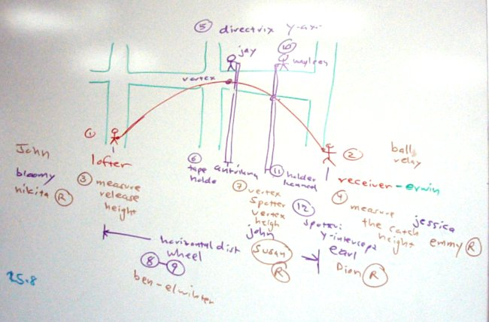
Each measurement position will need at least two people. One or more to handle equipment and one to record data. Data recorders will need pencil and paper. Those marked open may be substituted in for absentees or given a position not foreseen in the table below.
N | Name | Task | Measurement
1 | Marsela | Lofter
3 | Chersea | Release height equipment wrangler
3 | Gracelyn | Release height recorder
2 | Gloria | Catcher
4 | Joymina | Catch height equipment wrangler
4 | Cynthia Edward | Catch height recorder
1234 | Jessica | Assistant and pinch hitter
5 | Stephen | Directrix/vertex tape holder top
6 | Sheryl | Axis of symmetry tape holder bottom
7 | AJ | Vertex spotter
7 | Kodaro | Vertex recorder
10 | Angelina | y-axis tape holder top
11 | Desirae | y-axis tape hold bottom
12 | Charles | y-axis spotter
12 | Freddy | y-axis recorder
8 | Toshi | Surveyor's wheel operator
9 | Raynold | Surveyor's wheel loft location recorder (0 ?)
9 | Marissa | Surveyor's wheel y-axis recorder
9 | Hillario | Surveyor's wheel vertex recorder
9 | Dendes | Surveyor's wheel catch distance recorder
Open | Cynthia Harry
Open | Raynold
15 | Riantho | Time aloft equipment wrangler
15 | Zachery | Timer recorder
Open | Taylor
15 | Tracy | Time aloft equipment wrangler
15 | Wansesty | Timer recorder

