1. Describe the MyPlate dietary guidelines and recommendations

2. Which of these boxes of milk is healthier for you and why?

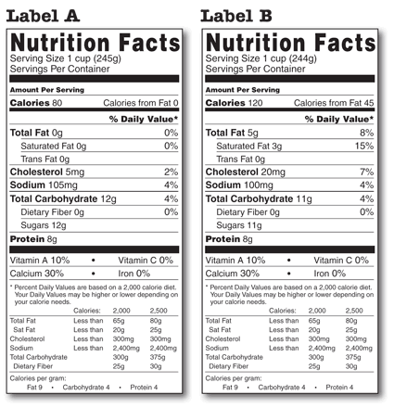
3. Food has seven components. What are the roles of the following four components in the body?
Proteins:

Carbohydrates:

Lipids (fats):

Water:
4. Of the above four, which component may contribute to high levels of cholesterol, heart disease, some cancers, and obesity?

5. Among nations of the world ranked from most obese to least obese as measured by Body Mass Index and seen in the film Ten Fattest Countries in the World, what is the rank of Micronesia?

6. According to the Al Jazeera 101 East program An Ocean Divided, what disease is affecting Tongans as young as 19 years old?

7. At the time this test was written, a former faculty member and the wife of another faculty member were in the hospital with complications of kidney failure associated with what disease?

8. What is your Body Mass Index (BMI)?

9. Is your body mass index healthy?

10. Over a five year period, what tends to happen to those who diet to lose weight (Explain why calorie-restriction weight loss regimens fail)?

11. What is the best way to lose excess weight?

12. The movie The Tarahumara – A Hidden Tribe of SuperAthletes Born to Run argues that we are born to run and born to run barefoot. What evidence does the movie cite that we are born to run and should run barefoot?

13. List some characteristics and capabilities of muscles that are trained to produce anaerobic efforts.

14. List some characteristics and capabilities of muscles that are trained to produce aerobic efforts.

15. Short track sprint stars depend on which of the two muscle capabilities: anaerobic or aerobic energy burning?

16. Long distance road runners depend on which of the two muscle capabilities: anaerobic or aerobic energy burning?

17. For cardiorespiratory fitness the textbook discusses a target heart zone rate. A week ago on Friday you calculated your target heart rate. On Monday Lee Ling noted that when you are exercising you cannot easily determine what your heart rate is. To determine if one is working out at their peak heart-lung benefit rate, what did Lee Ling suggest?

18. People with a heart condition can exercise but only under what conditions and restrictions?

19. Define overuse injuries.

20. What are heat cramps?

21. What is heat exhaustion?

22. What is heat stroke?

