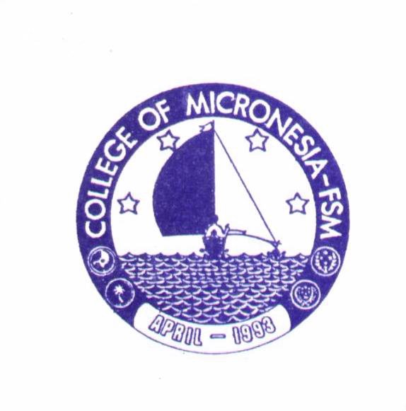
COLLEGE of MICRONESIA
Chuuk Campus
Box 879 Weno, Chuuk
F.S.M. 96942
(691) 330 - 2689

Date : Originally sent : July 8, 2002
Revised : July 31, 2026

Memorandum

To : Joakim Peter, Director, COM-FSM, Chuuk

From : Stephen Richmond
Alton Higashi

Subject : Computer graphics class and certificate program

Jojo,

Attached please find a copy of a course description and outline and for a course tentatively titled Introduction to Computer Graphics. The intent of the course is to introduce students to computer graphics programs that are not generally taught to students in other computer classes. The genesis of the idea was to attempt to provide an alternative course for students enrolled in the Vocational Certificate of Achievement in Carpentry program and for those students who are in search of electives in the General Studies Program. It may also appeal to students who wish to concentrate on computer use as a means of self expression and for generating potentially saleable products.

Initially it was felt that this introductory course could be a substitute for the current CA-100 requirement for the Vocational programs, but it soon became evident that there is much more to computer graphics than would be applicable to Carpentry Certificate programs.

In addition, in an effort to provide some degree of gender equity, it is felt that there is every reason to believe that both men and women can benefit from this course(s) in terms of making decisions as to housing and furniture design. Women especially could use their perceptions as to what constitutes a functional house layout as a basis for plan development. Women also tend to spend more time in the home and are perhaps more sensitive to the aesthetic needs of the home environment.

Encouraging economic development, in Chuuk State, may benefit from the development of self employed craftspeople. While handicrafts serves its purpose in relation to the tourist market, local self-employed designers are also considered necessary to address the need for locally produced items intended for local use. This program in Computer Graphics may provide the impetus for some participants to proceed in that direction.

Having decided that the computer graphics course would constitute the beginning level of understanding and competence in alternative computer use, it was felt that development of additional expertise in the use of the programs presented in the introductory course should become the basis for a Certificate of Achievement in Computer Graphics.

Certificate of Achievement in Computer Graphics.

Most certificate programs are composed of four core courses and five or six courses specific to the area of study for the certificate. A suggested course sequence for this certificate follows

Core Courses
- Technical English-ESL-051 (3 credits) This is a standard course requirement for all vocational certificate programs.

- Technical math MS-100 (4 credits) This is a standard requirement for all vocational certificate programs.

- Small business management. BU-097 (3 credits) Standard requirement.

- CA-100 or perhaps CA-095 (3 credits) One of these courses, (to be decided later which one) is a prerequisite for all of the other computer courses. The intent is to be sure that the students in the certificate program have the basic knowledge needed to operate a computer. The course that provides the widest familiarity with the working of a computer is desirable. The students should know things like opening programs, naming and saving files, saving things to disk, etc. It is helpful, too, to have a basic understanding of word processing at least in terms of typing skills, spelling checking, text formatting, font selection, copying, cutting and pasting, changing font size, and so forth.

Total core credits (13 credits)

Technical requirements:
Introductory information:
- Students who participate in this certificate program will be required to maintain a portfolio of their work in each of the required technical courses. The portfolio would become major part of the students’ performance evaluation procedure. It would also be a potent tool for students who apply for work in businesses that rely on published graphic materials in their day-to-day operation.

- Each of the technical courses is valued at 4 credits due to the lab component of the course. Experiential learning and experimentation are needed for the development of competency in the use of the programs to be presented.

- Introduction to Computer Graphics (4 credits)
(See attached course outline)
This course is the prerequisite for all of the following courses. In this course, various computer programs specific to desktop publishing will be introduced with a maximum amount of hands-on computer work. The students need time to gain confidence in the use of computers and with some of the graphics programs that are available. The following courses will expand on the use of programs started in the introduction course.

- Digital photography, composition and image transformations. (4 credits)
(Course outline not yet developed)
This course would be designed to provide the students extensive practice in taking pictures and in composing images, modifying the images both in terms of quality and content, composition and printing images. With the digital camera software there is often a printing option for producing either plain photographs or photo albums. In addition to camera work, drawings and scanned images will figure prominently as source material for use in the course.

- Publishing and flatwork layout and development (4 credits)
(Course outline not yet developed)
This course is intended to provide students with further information and experience in using images and combining them with text and other layout elements in the development of printed projects such as brochures, banners, advertisements and the like. Microsoft Publisher or some other publishing program would be the basis of the course and the interaction of that program and other programs as sources of images would be part of the widening interconnections among graphics programs.

NOTE: The students would choose one of the following three options.

4. PowerPoint presentations (option one) (4 credits)
(Course outline not yet developed)
This course is intended to further develop the students’ skills in information presentation. Microsoft PowerPoint program would be the basis for this course. Using a variety of visual resources combined with student produced narrations or soundtracks the students will prepare informational presentations, entertainment slide shows or other types of public presentations.

- Housing design (option two) (4 credits)
(Course outline not yet developed)
This course is intended to expand on the students, understanding of the computer for use as a tool for developing floor plans and 3-dimensional views of their projects. This course might be taken in conjunction with the Blue print sketching and interpretation course that is presently being offered as part of the Carpentry program.

Note: Blueprint sketching and interpretation could be the basis for the students’ understanding of the needs of residential structures, internal traffic patterns room sizes, and other design considerations. If the Blueprint course is used as a prerequisite, then the Housing Design course should be called Advanced Housing Design since it develops design sense using the computer as the means for producing blueprints.

- Furniture design (option three) (4 credits)
(Course outline not yet developed)
Through the use of a CAD program, (Computer Assisted Design) student will learn to design useful and decorative furnishings for use in the home. Ergonomic parameters for home fixtures would be one consideration for the students during the design development process.

Note: It may be beneficial to develop an additional course in the area of functionality of furniture and its relation to the individual using it. If this course is needed then the Furniture design course should be renamed Advanced Furniture Design.

7. Practicum (4 credits)
(Course outline not yet developed)
This final course would enable the successful student to combine the skills learned through the previous courses into a community based on site experience in product development. The intent would be to work with government agencies, businesses, churches and other entities to assist them in developing brochure material, advertising layouts, promotional materials public visual presentations and so forth. The specifics of what the student would produce would be based on the needs and activities of the collaborating agency or business or individual. In addition, part of the students’ activity in the practicum could be to help train people employed in the various entities to be able to help themselves in developing materials for use by the agencies and businesses. The students would function as an on site instructor in Computer Graphics

As a way of assisting the college in assessing the progress of each of the students, the participating agencies, businesses, or individuals would be asked to fill out progress reports using a COM developed student progress and performance evaluation report form.

Technical requirements (20 Credits)
Certificate total (33 Credits)

Among the current COM students there is a strong interest in learning the kinds of skills that are envisioned for this Certificate of Achievement if Computer Graphics. With the information age upon us the college would be somewhat remiss if it did not provide at least one certificate program that promoted the use of technological tools in areas other than standard business management and accounting activities and took advantage of the artistic talents of members of the student community.

Additional information:

A committee to develop ideas for the future direction of the COM-FSM, Chuuk Vocational Education program was established in 2001 to be chaired by Switer Eter with members to be Stephen Richmond and Alton Higashi. As a result of several meetings between Richmond and Higashi, the Computer Graphics Certificate of Achievement program concept was developed.

Prior to the establishment of the vocational education committee another position paper entitled The Applied Arts Program was written with the intent to define an alternative structure for the vocational education program at COM-FSM, Chuuk Campus. This paper was submitted for consideration, but was not acted upon. It is therefore resubmitted for a second time with the hope that these two documents can be the basis for a renewed emphasis on the Vocational Education activities for the Chuuk campus and for all the state campuses in the COM FSM college system

We ask that you review these two papers and provide your comments, criticism and suggestions. They will be very much appreciated.

Thank you for your interest.

Stephen Richmond

Alton Higashi

cc : Switer Eter

