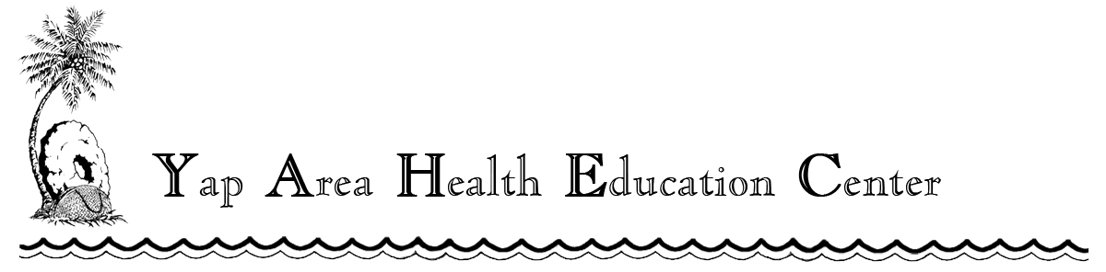

To: Jean Thaulog, College of Micronesia
From: Mark Durand

Subject: Revised proposal for COM Community Health Worker/Health Assistant certificate program.

Date: January 29, 2006

Cc: Leona Tamag, Lt. Gov Joe Habuchmai, Dr Victor Ngaden, Dr Arthur Yolwa, Dr James Edilyong, Dr Lizuta, Dr Arthur Yolwa, Dr Vincent Tafleimal, Dr Kelley Withy, Julie Yoruw, Dana Lee Ling, Marcus Samo, Secretary Nena, Dr Bosco Buliche

In follow-up to our conference call of January 13, 2006, I am submitting the attached curriculum revision proposal for consideration of adoption by the COM curriculum committee, and the COM Board.

This document has been revised to include the suggestions that were brought up in our last conference call including:
- The inclusion of development of ethical and client centered attitudes in the statement of program goals
- The creation of separate courses for Mental Health and Dental Health.
- A provision for waiving the “tabella” for health workers who have already had sufficient clinical experience

Thanks to you, the members of your staff and the staff of COM-Pohnpei state campus for the helpful suggestions and to the curriculum committee and the COM board for taking the trouble to consider this proposal.

