Curriculum Handbook

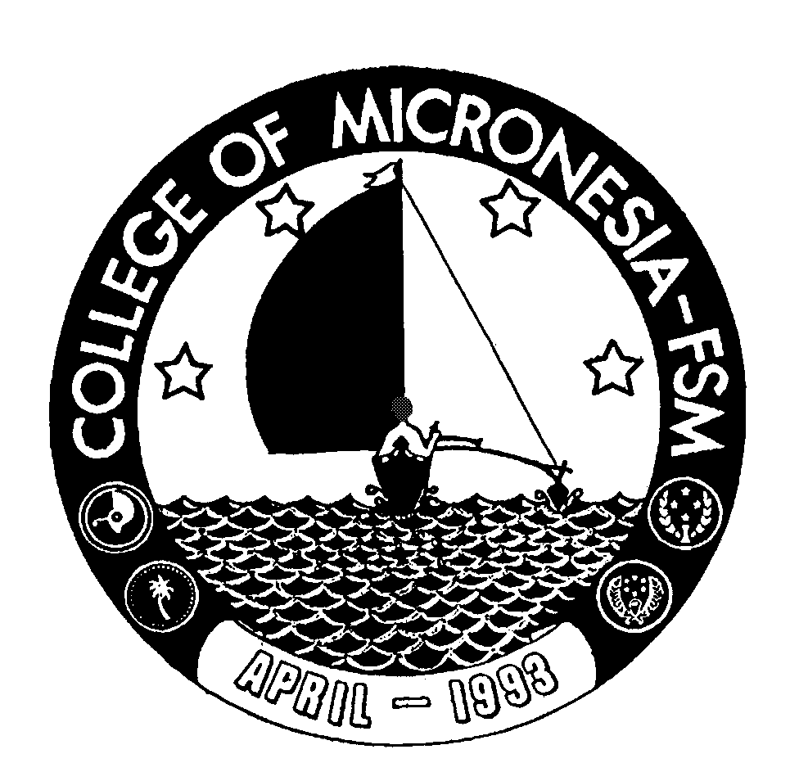

College of Micronesia-FSM

School Year 2004-2005

