COLLEGE OF MICRONESIA-FSM
P. O. Box 159
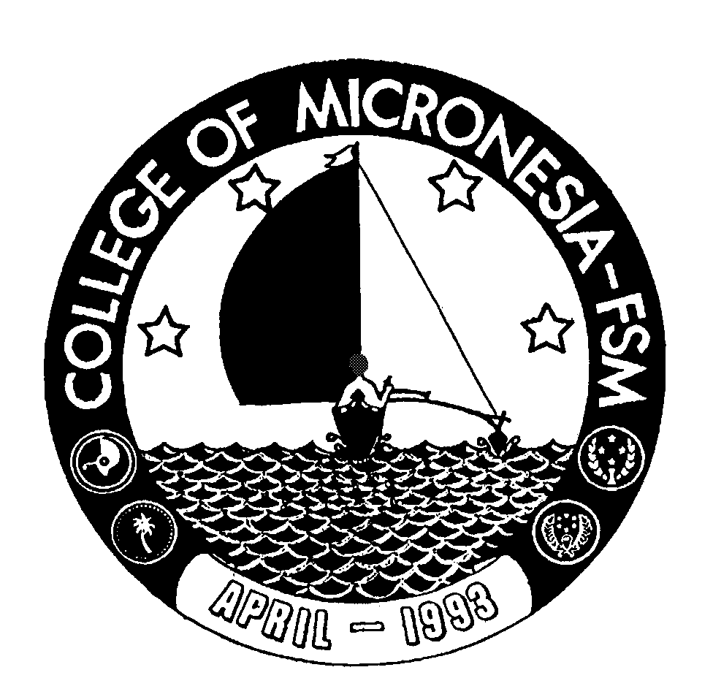
Kolonia, Pohnpei FM 96941

Associate of Arts Degree
in
MICRONESIAN STUDIES

___________________________________ _______________________________
Name State/Republic

Date of First Test |  | Placement Test
 | English  Listening/Speaking |  | English  Structure | English  Reading | English  Total | Math

GENERAL EDUCATION CORE REQUIREMENTS |  |  |  |  |  |  | MAJOR REQUIREMENTS (27 Credits)
English (9 credits) |  |  |  |  | SS 101 Introduction to Political Science |  |  |  |  |  |  | 3____
EN 110 Advanced Reading | 3_____ |  |  |  | SS 120 Introduction to Geography |  |  |  |  |  |  | 3____
EN 120a Expository Writing I | 3_____ |  |  |  | Ss 125 Pacific Geography |  |  |  |  |  |  | 3____
EN 120b Expository Writing II | 3_____ |  |  |  | SS 195 Micronesian Cultural Studies |  |  |  |  |  |  | 3____
 |  |  |  |  | SS 200 Research Methods |  |  |  |  |  |  | 3____
Mathematics (3 credits) |  |  |  |  | SS 205 Micronesian Government & Politics |  |  |  |  |  |  | 3____
Any 100 level or above |  |  |  |  | SS 212 Economy of Micronesia |  |  |  |  |  |  | 3____
Mathematics course | 3____ |  |  |  | SS 220 Contemporary Issues of Micronesia  SS 280 Directed Study: Selected Topics |  |  |  |  |  |  | 3____  3____
Natural Sciences (7 credits)
A science course w/lab, AG 110 or 140 and | 4____
A non lab science or AG 101 | 3____ |  |  |  | Open Electives (6 credits)
 |  |  |  |  | _________________________ |  |  |  |  | 3____
Social Sciences (3 credits) |  |  |  |  | _________________________ |  |  |  |  | 3____
SS 150 History of Micronesia | 3____
Computer Application (3 credits)
CA 100 Computer Literacy | 3____
Exercise Sports Science (1 credit)
ESS course  Humanities (3 credits) | 1_____
Any course in Art, Music,
History, Philosophy, Language or  Culture may be taken | 3_____
 |  |  |  |  |  | Total Graduation Requirements |  | 62 credits

