COLLEGE OF MICRONESIA-FSM
P. O. Box 159
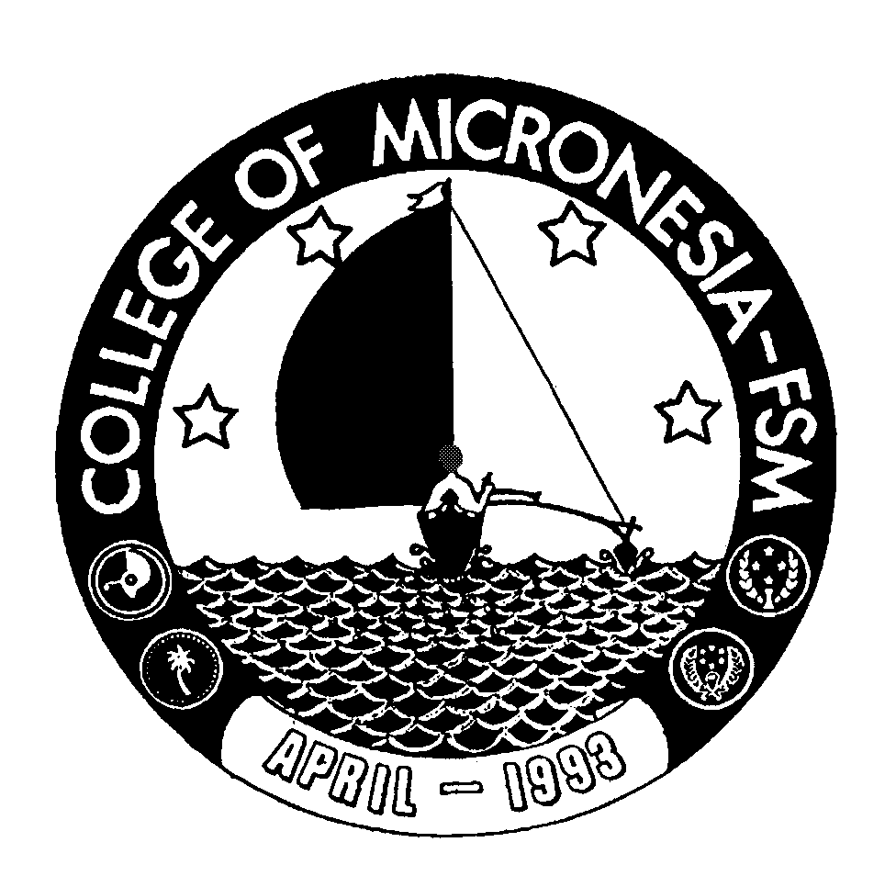
Kolonia, Pohnpei FM 96941

Associate of Arts Degree
in
LIBERAL ARTS
__________________________________ ___________________________
Name State/Republic

Date of First Test |  | Placement Test
 | English  Listening/Speaking |  | English  Structure | English  Reading | English  Total | Math

GENERAL EDUCATION CORE REQUIREMENTS |  |  |  |  |  | MAJOR REQUIREMENTS
English (9 credits) |  |  |  |  | EN/CO 205 Speech Communication |  |  | 3_____
EN 110 Advanced Reading |  | 3____ |  |  | SC 101 Health Science |  |  | 3_____
EN 120a Expository Writing I |  | 3____ |  |  | SS 130 Introduction to Sociology |  |  | 3_____
EN 120b Expository Writing II |  | 3____ |  |  | SS/PY 101 General Psychology |  |  | 3_____
 |  |  |  |  | Specialty (6 credits)
 | Mathematics (3 credits) |  |  |  | Any two courses from one of the following group:
 | Any 100 level or above  Mathematics course |  | 3____ |  | Social Sciences  SS_________________________  SS_________________________  OR |  |  |  | 3_____  3_____
 | Natural Sciences (7 credits)  A science course with lab or AG 110 or 140 |  | 4____ |  | Natural Sciences  SC___________________________ |  |  | 3_____
 | and A non-lab science or AG 101 |  | 3____ |  | SC________________________ |  |  | 3_____
 |  |  |  |  | English Elective (3 credits)
 | Social Sciences (3 credits) |  |  |  | Any 200-level English course:
 | SS 150 History of Micronesia |  | 3____ |  | EN 201, EN 202, EN 203, EN 204,
 |  |  |  |  | EN 205, EN 206, EN 207, EN 208,
 | Computer Application (3 credits) |  |  |  | EN 209, EN 210, EN 213 or
 | CA 100 Computer Literacy |  | 3____ |  | MM 101 |  |  |  |  | 3____
 | Exercise Sports Science (1 credit) |  |  |  | Humanities Elective (3 credits)
 | ESS course |  | 1____ |  | Any course in Art, Music, History,
 |  |  |  |  | Literature, Philosophy, or Language
 | Humanities (3 credits) |  |  |  | may be taken |  |  |  |  | 3____
 | Any course in Art, Music, Literature
 | History, Philosophy, Language, or  Culture may be taken |  | 3____ |  | Open Electives (9 credits)  _______________________ |  |  |  |  | 3____
 |  |  |  |  | ______________________  ______________________ |  |  |  |  | 3____  3____
 |  |  |  |  | Total Graduation Requirement |  | 62 credits

