COM-FSM Curriculum Handbook Rev_ 9/97

Appendix D
College of Micronesia -FSM

COURSE MODIFICATION REQUEST

EN 209 - Introduction to Religion English
Course Number and Title Department

_____________________________ ___________
New Course Number and Title Department

New Course Objectives:
___________________________________________________________________________
___________________________________________________________________________
___________________________________________________________________________

New Course Description:
EN 209- Introduction to Religion .............................. 3 credits Prerequisite: EN 110
This course introduces the study of religion by examining some of the world's
major religions, past and present.

Justification for Revising the Course: Catalog

7/699
Chairperson, Curriculum Committee Date
7/7/99 Date

College of MICRONESIA

Pohnpei Yap Truk Palau Kosrae Marshall Islands
COMMUNITY COLLEGE OF MICRONESIA Box 159, Kolonia, Poh FSM 96941 º
Phone: 320-2479/24801248lr2462
OU j RS COVER
E PAG
Introduction to Religion EN 209 Course Title Department and Number
Course Description: The course will present, clearly and objectively, some of the great religious ideas of mankind. It will examine in some detail the tenets and the history of the great religions of the world. Students will gain a clear idea of the varieties of religious experiences and philosophies.
Course Prepared by: Bernard Mullins Pohnpei State

Hours/week No. of Weeks Total Hours Sem. Credits
Lecture 3 x 16 = 48 = 3
Laboratory ___ x __________ = _______ = __________
Workshop ____ x __________ = _______ = __________

Total Semester Credit = 3

Purpose of Course: Degree Requirement _______

Degree Elective _______

Certificate _______

Remedial _______

Other _______

.. .. ............ . --z

Date approved by CommitteE
Date app roved by President

The following image block was retained for historical purposes.
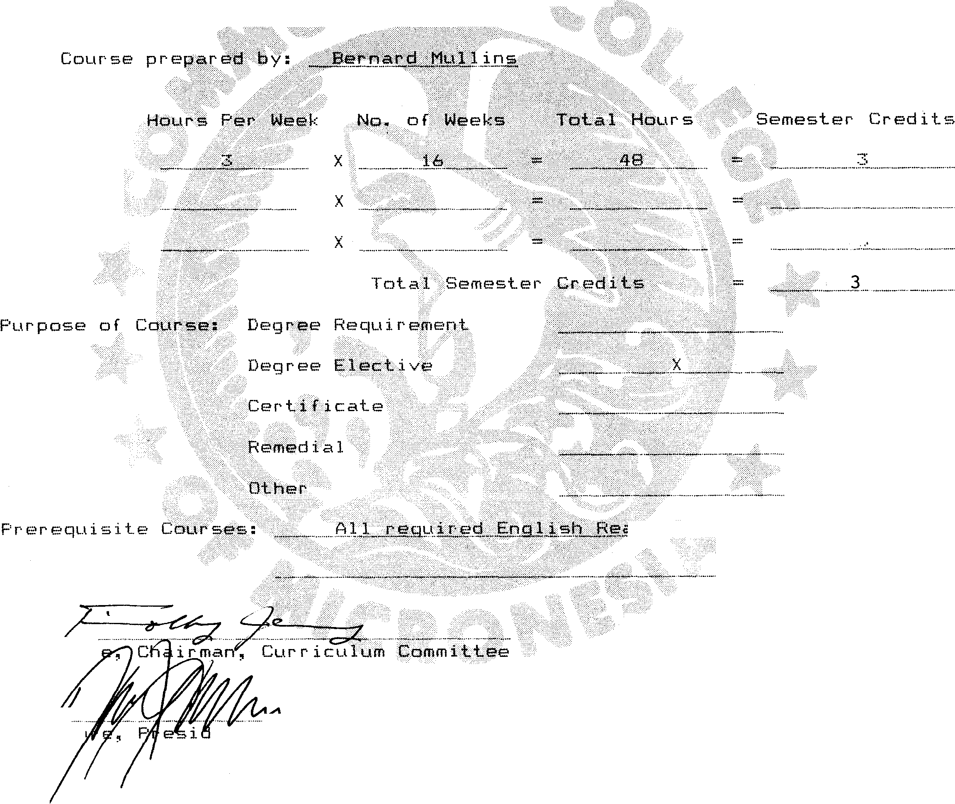


Accredited by the Western Association of Schools & Colleges


Students will learn to discriminate among myth, religion, and philosophy. They will arrive at an understanding of the meaning of religious belief, religious experience, and religious variety. The course will very broadly survey: polytheistic beliefs in ancient. Greece and Rome; Judaism, the first great monotheistic religion; Christianity, both Catholic and Protestant; Islam, the third great monotheistic religion. The two great Eastern religions, Hinduism and Buddhism, will then be considered. The course will conclude with a belief introduction to early Greek philosophy, to enable the student to distinquish clearly between philosophy and religion.

Specific Objective:
At the end of the course, students will :
1) demonstrate an awareness of the development of the major religions beginning with the polytheistic practices in Greece and Rome.
2) be able to discuss, in depth, the sequence of monotheistic religions; Judaism, Christianity and Islam, as well as their origin, development and the major tenets of each.
3) Students will also demonstrate competence in discussing the two major eastern religions; Hinduism and Buddhism, their development and history
Course Content
I. Introductory
1. What do we mean by "religion" and "religious experience"?
2. How is religion to be differentiated from myth and philosophy?
II. Polytheism
1. Its prevalence; Greece and Rome as specific examples.
2. In what way were these many gods believed in? Were they more than personifications of natural forces, and such ideas as Harmony and Justice''?

III. The Great Monotheistic Religions
The general background history of each will be given, as well as a consideration of the basic tenets of each. They will be considered in chronological order.

1 . Judaism
2. Christianity
a. Its origin b. its debts to Judaism and to Greek thought c. the reformation: the origin of Protestantism
IV. The Great Eastern Religions
The general background history of each will be described, as well as the basic tenets of each.
1. Hinduism
1. the Upanishads: religion and philosophy
2. the "pluralism" of gods -- and "the one''
2. Budd h ism
a. its history and debts to Hinduism
b. Hinayana, Mahayana, and Zen Buddhism
V. Early Greek Philosophy
The aim is to show, as is stated in the Introductory section of the course, how philosophy differs from religion and myth.
1. Formal teacher presentation
2. Textbook and outside reading
3. Class discussions will be encouraged
4. Staff members, and island residents, whose, faith is
not Christian (e.g., is Jewish or Buddhist) may be asked to speak to the class about the personal experiential "meaning" of their faith, as well as its customs, observances, rites, requirements etc.

Evaluation.
The A,B,C,D,F grading system as defined by CCM policy will
used.
Attendance:
Students will be required to attend all classes, except in cases of illness or other family emergency. Official CCM attendance policy will be very strictly adhered to. Details of making up missed work will be discussed between student and instructor.
Text:
The_Religion of man, Huston Smith, Mentor Books
A variety of handouts will be prepared by the instructor

