College of Micronesia – FSM
Spring 2012
Enrollment & Achievement Data Summary

Total student enrollment for spring 2012 was 2544 compared to 2392 students in spring 2011. The National Campus had 958 students followed by Pohnpei with 693, Chuuk 428, Kosrae 244 and Yap 221. Continuing students composed the greatest portion of students at 91% with new students representing 5% of the overall student population and returning students with 4%.

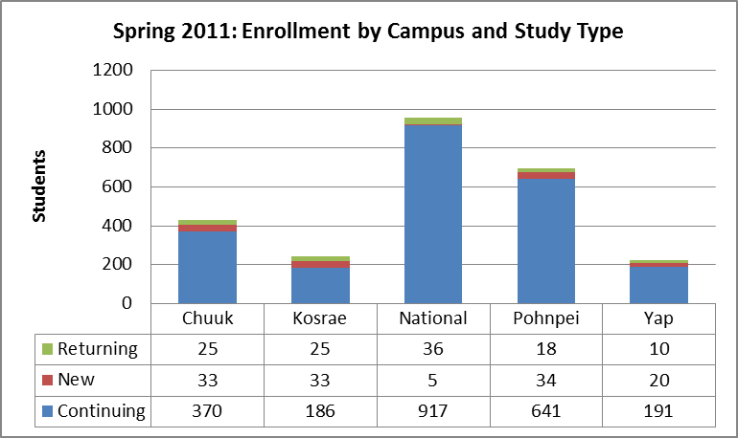 | 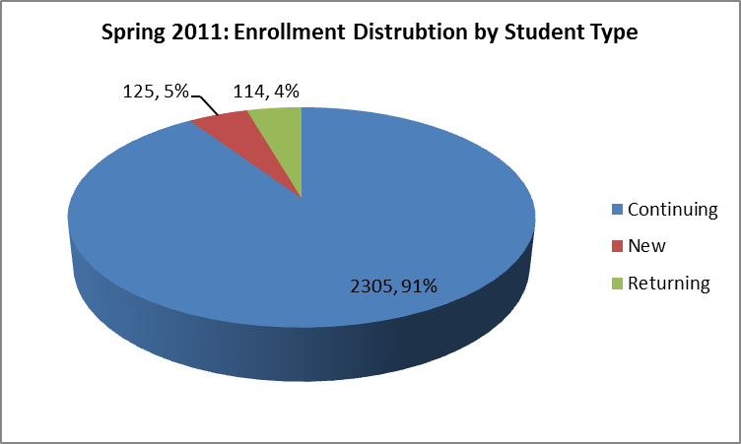

Pohnpeians continued to represent the largest component of the college community at 55% overall and 76% at the National campus. Chuukese represented 20% of the overall student population and 8% of the National campus student population. Both of the Chuukese figures are significantly below the 47.4% of the Chuukese component of the overall FSM population.

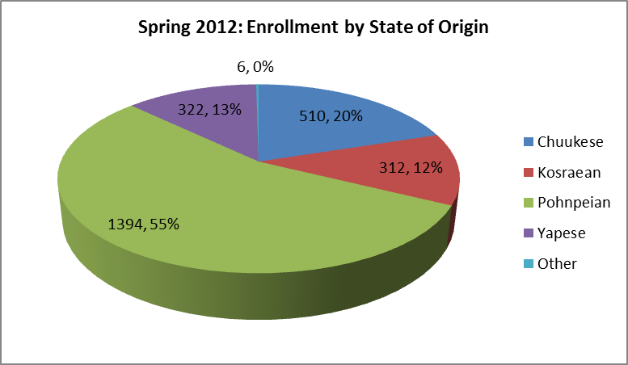 | 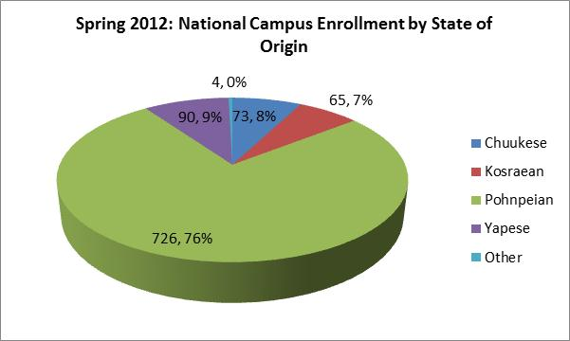

The total college credits of 29776 for spring 2012 exceeded the spring 2011 total by 1034 credits. 78.4% of college students were in good academic standing (GPA 2.00 or greater) at the end of the spring semester. The range in good standing by campus was Yap campus with 85.5% of students in good academic standing down to Pohnpei campus’s 71.1%.
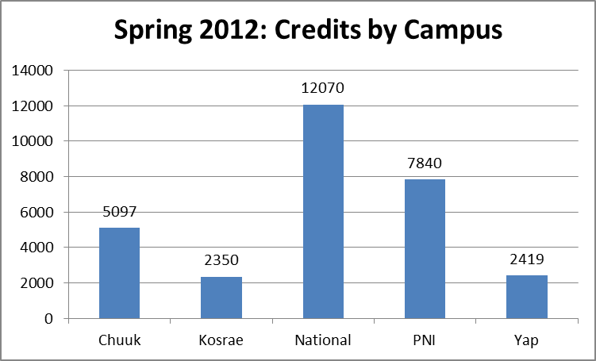 | 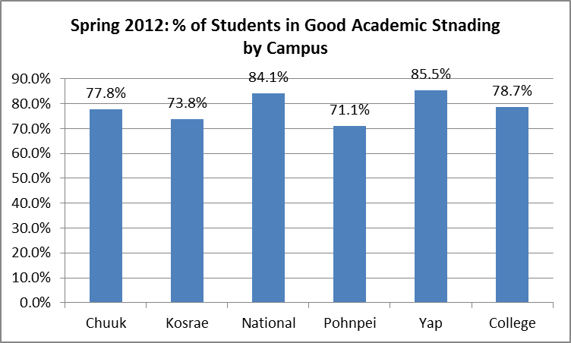

The figure below shows the comparison between credits attempted and credits earned by campus. On average students attempted 10.3 credits and earned 8.6 credits. 39.8% of students earned 12 or more credits during spring semester. Approximately 50% of continuing and 47% of returning students at the National campus earned 12 or more credits along with 50% of new students at Pohnpei campus. Earning 12 or more credits is a good indicator if students are making progress toward obtaining a degree in the 150% of time established by new PELL grant eligibility requirements.

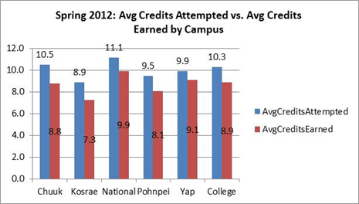 | 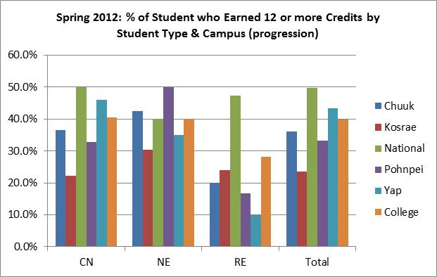

192 students graduated in spring 2012 with Pohnpeians representing 58% of the total graduates. The breakdown by degree type was 64 for associate of arts degrees, 60 for associate of science degrees, 9 associate of applied science degrees, 31 certificates, and 27 third year certificates. Additional there were 2 graduates of the Bachelor of Arts in Elementary Education the college offers in partnership with the University of Guam.

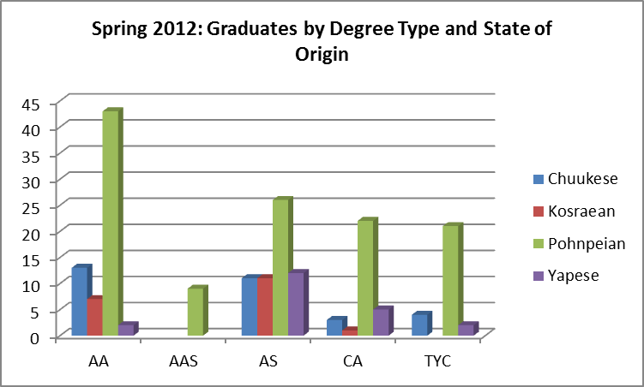 | 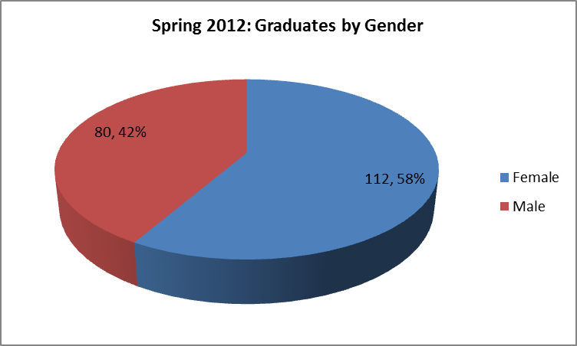
For additional information, please contact the office of Institutional Research and Planning at rschplanning@comfsm.fm or visit their website http://www.comfsm.fm/irpo/.

