College of Micronesia - FSM
Key Enrollment Data Summer Semester 2012

For summer 2012, 1275 students attended the various campuses of the college. The distribution by campus was Chuuk – 199, Kosrae – 144, National – 557, Pohnpei – 267, and Yap – 108. The chart below shows enrollment broken out by student type.

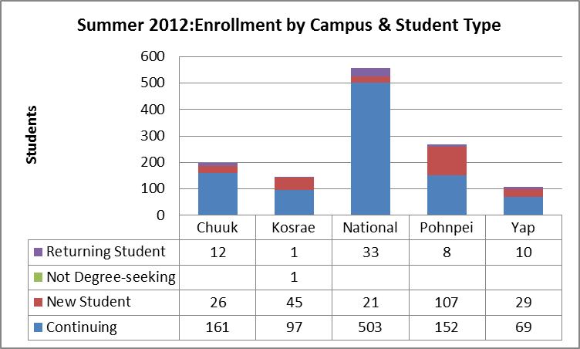

Enrollment for summer 2012 was impacted by changes in PELL grant eligibility including loss of the year round PELL. Overall, there was a 39.5% reduction in the number of students from summer 2011 (2109 students enrolled) to summer 2012. In terms of credits, the reduction was somewhat greater at 42.3% from summer 2011 to summer 2012.

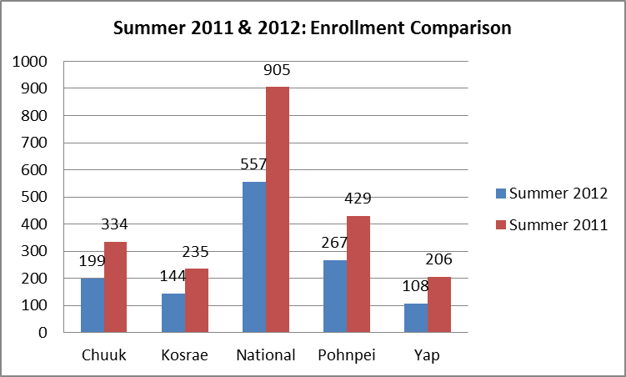 | 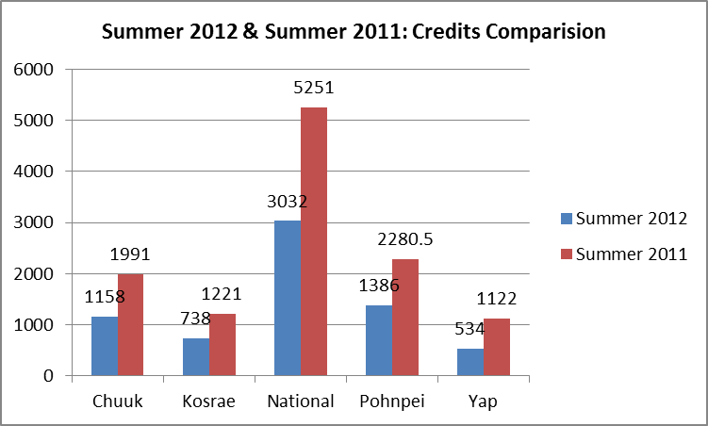

Enrollment by state of origin can be seen in the pie charts below for both the college and the National Campus. Enrollment patterns for state of origin are similar for summer 2012 and 2011. Pohnpeians represented 55% of the overall summer student population and 80% of the national campus student population in both summer 2011 and 2012. At the national campus for summer 2011, Kosraean’s represented 4% of the student population, with Yapese and Chuukese at 7%.

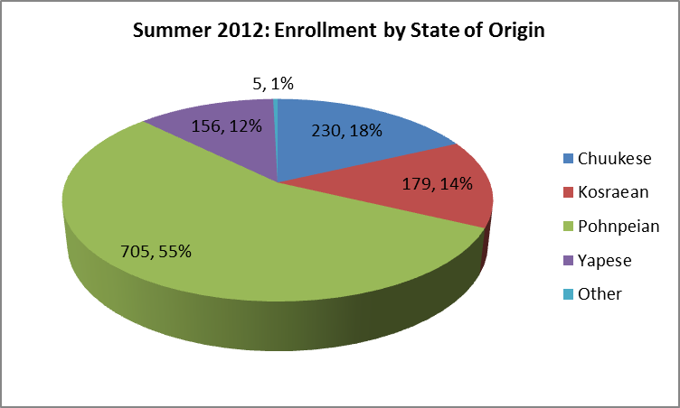 | 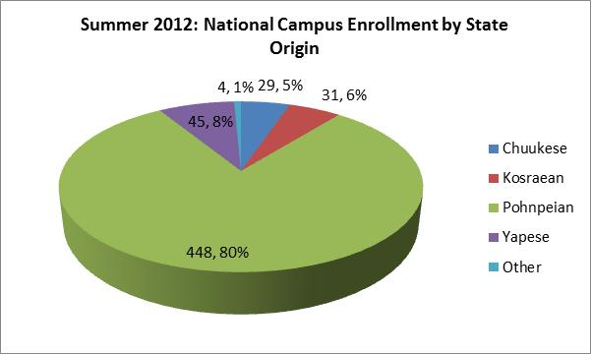

Gender distribution was 56% female and 44% male. Gender difference for the summer was highest at Yap campus with 73% female students and only 27% male. Kosrae was the only campus where males (51%) were a greater part of the student population than females. Overall students at the college averaged 5.4 credits compared to an average of 5.6 credits for summer 2011.

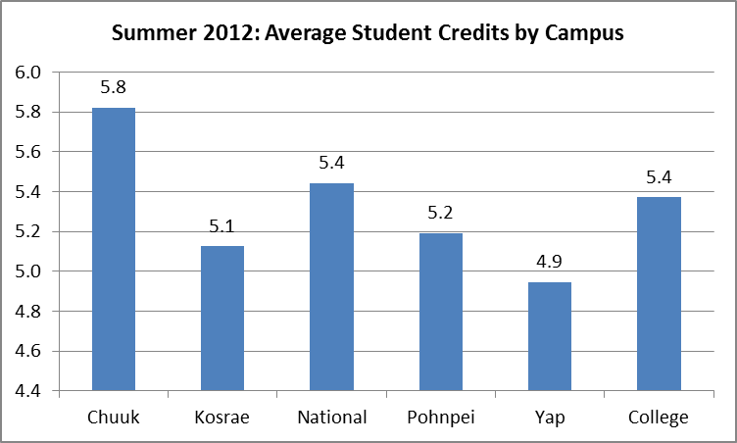 | 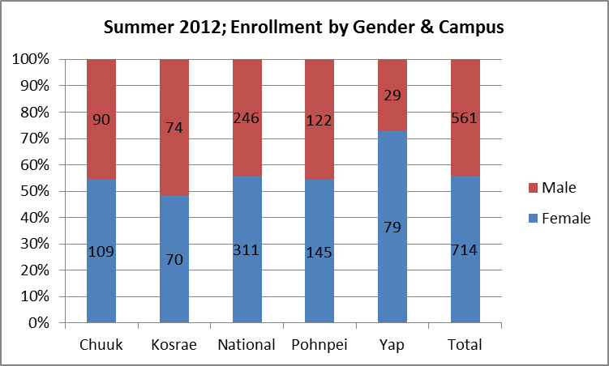

For additional information, please contact the office of Institutional Research and Planning at rschplanning@comfsm.fm or visit their website http://www.comfsm.fm/irpo/.

