Degree and Certificate Programs Offered
Fall Semester 2012

Programs & Degree
Health Career Opportunities Program | AA
Liberal Arts | AA
Micronesian Studies | AA
Teacher Preparation | AA
Building Technology | AAS
Electronics Technology | AAS
Telecommunications | AAS
Agriculture & Natural Resource Management | AS
Business Administration | AS
Computer Information Systems | AS
Hospitality and Tourism Management | AS
Marine Science | AS
Nursing | AS
Public Health | AS
Teacher Education - Elementary | AS
Elementary Education | BA
Agriculture and Food Technology | CA
Basic Public Health | CA
Bookkeeping | CA
Building Maintenance and Repair | CA
Cabinet Making/Furniture Making | CA
Career Education: Motor Vehicle Mechanic | CA
Carpentry | CA
Construction Electricity | CA
Electronic Engineering Technology | CA
Health Assistant Training Program | CA
Law Enforcement | CA
Nursing Assistant | CA
Refrigerator and Air Conditioning | CA
Secretarial Science | CA
Trial Counselor | CA
Public Health | TYC
Teacher Preparation - Elementary | TYC
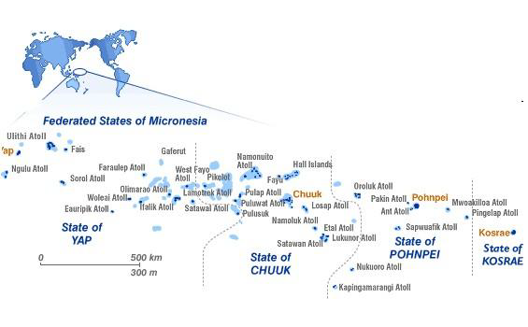

COM-FSM serves the Federated States of Micronesia, a small island developing state in the western Pacific. COM-FSM operates four State Campuses in Chuuk, Kosrae, Pohnpei and Yap Sates with a National Campus located in Pohnpei State and a Fisheries and Maritime Institute in Yap State.

College of Micronesia – FSM
P.O. Box 159
Kolonia, Pohnpei, FM 96941
Phone: (691) 320-2480
Fax: (691) 320-2479
Website: www.comfsm.fm
For additional information contact rschplanning@comfsm.fm

College of Micronesia - FSM

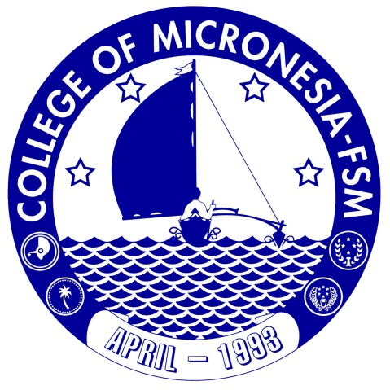

Factsheet
Spring 2013

Joseph M. Daisy, EdD.
President and Chief Executive Officer

Accredited by the Accrediting Commission for Community and Junior Colleges (ACCJC) of the Western Association of Schools and Colleges (WASC)

Enrollment Summaries Fall Semesters by Institution, Campus and State of Origin

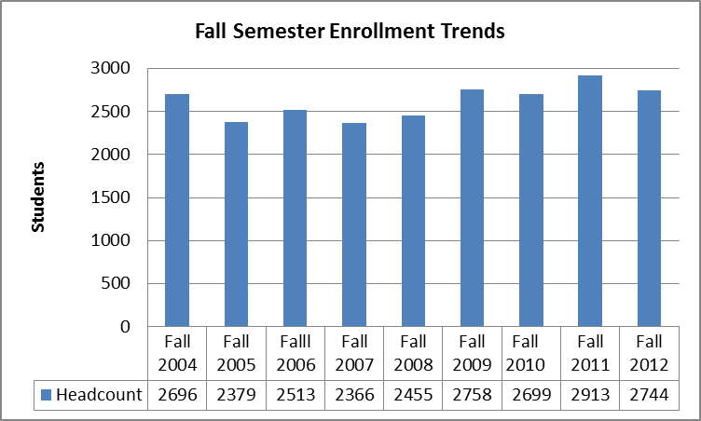
Enrollment for Fall Semester 2012 was 2744 students.
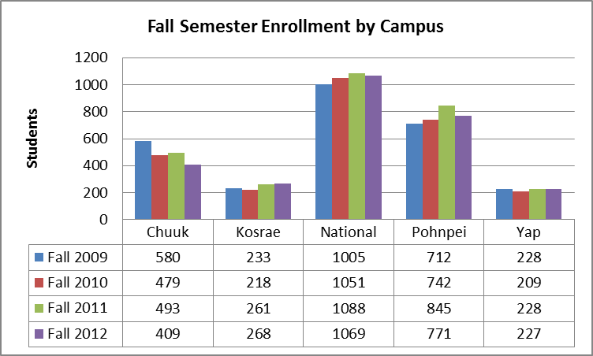
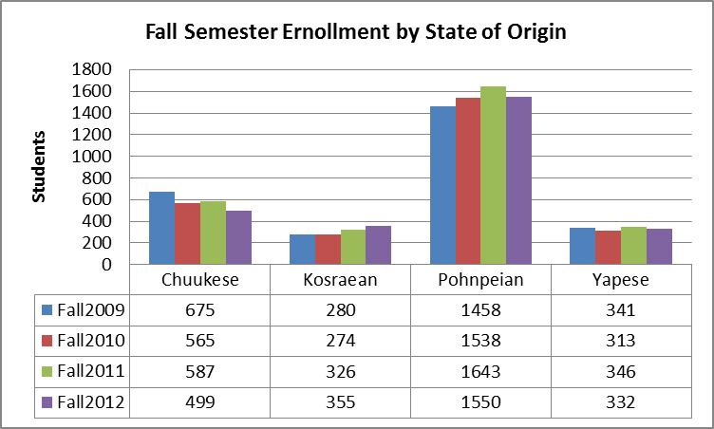
In Fall 2012 Pohnpeians represent 57% of the college population followed by Chuukese at 18%, Kosraeans at 13% and Yapese at 12%.
Program Graduates Total and Current Graduation Rates

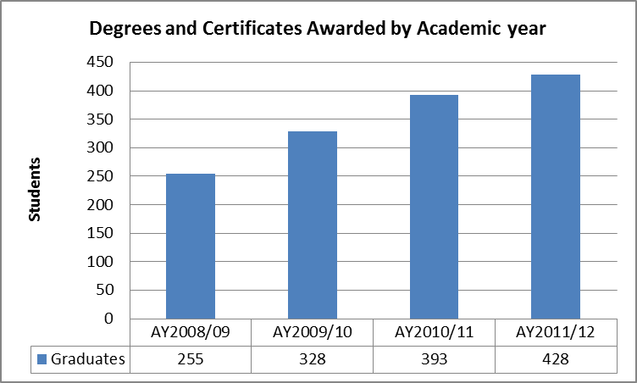
In Academic year 2001/12, 428 students received associate degrees and certificates.

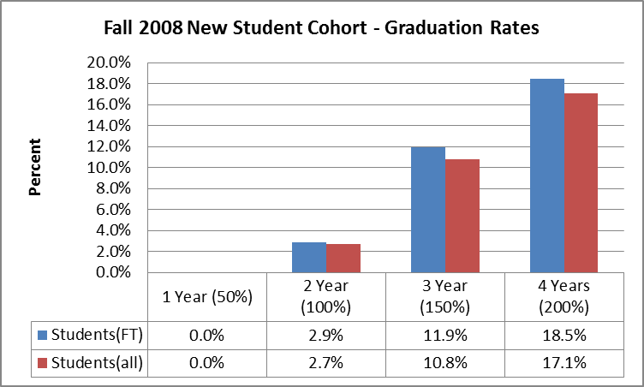
Graduation rates are based on cohorts of new students in Fall Semesters.

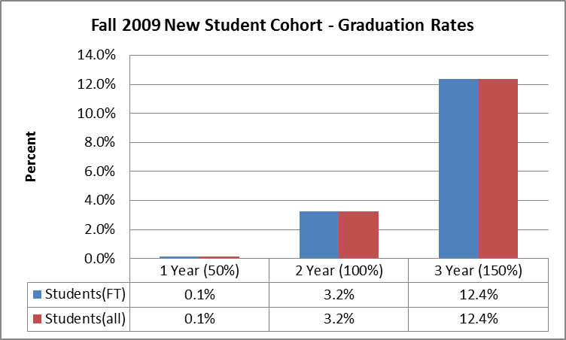

Gender and Retention

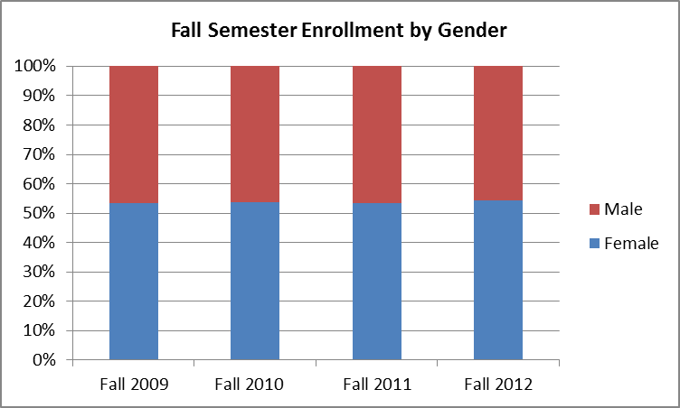
In Fall 2012 females represented 56% of students.
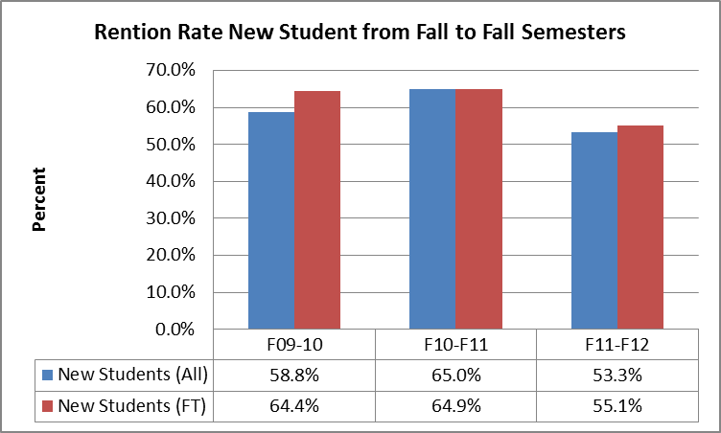
Retention rates are based on the number of new students in Fall Semester who return the next Fall Semester.

Some additional data:
- FY 2013 operations budget of $10; 731,351 was supported by Tuition and Fees $6,931,351, FSM General Fund $700,000, and the Compact Education Sector Grant $3,100,000.
- FY 2013 FSM FMI budget was $655,110 funded by the FSM General Fund
- FY 2013 SEG budget was $689,948 funded by the Compact SEG fund.
- Fall 2012 student mean age was 22 with a median age of 20.
- Fall 2012 course completion rates for a ABCorP grade was 68.3% and 78.0% for ABCDorP grades.
- Fall 2012 had 101 full time faculty (including ICs and DAP) with 45% Micronesians and 55% non-Micronesians.

