Use 12 point Tahoma font to produce this one page document you hold in your hand.

Outline

- PreContact
  - Traditional society
  - Clan title structures
    - Togusrai
    - Village chiefs
  - Land units
- Missionaries and Maniacs
  - Whalers
  - Privateers
  - Missionaries
- German era
  - Copra
- Japanese period

This is centered
Sphinx of black quartz,
Judge my vow.


Italics left justified: The public was amazed to view the quickness and dexterity of the juggler.

Paintbrush picture, perfect square with thick purple border and a yellow center, floating on the right side of the page as shown:
Right justified Times New Roman 12: Forsaking monastic tradition, twelve jovial friars gave up their vocation for a questionable existence on the flying trapeze.

Use Word to make the following table including the header with shading. Right justify the right column as shown:
Municipality | Population
Lelu | 2566
Malem | 1552
Utwe | 1130
Tafunsak | 2415

2. Matching:
A. _____ bold |  | i. Sphinx of black quartz, judge my vow.
B. _____ cursive |  | ii. Sphinx of black quartz, judge my vow.
C. _____ fantasy |  | iii. Sphinx of black quartz, judge my vow.
D. _____ italics |  | iv. Sphinx of black quartz, judge my vow.
E. _____ serif |  | v. Sphinx of black quartz, judge my vow.
F. _____ underline |  | vi. Sphinx of black quartz, judge my vow.

3. Produce the following table and pie chart using Excel:
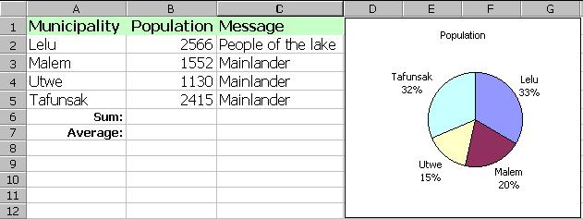
Your chart should look the one above, including labels, percentages, but NO LEGEND.
4. Calculate the total population of Kosrae using a function placed into cell B6.
5. Calculate the average population per municipality using a function placed into cell B7.
6. In column C use an if-then function to produce the results seen above:
If “Lelu” Then “People of the lake” Else “Mainlander”
7. What day of the week were you born on? ____________________________
8. Enter the following table into Excel. In cell D2 enter the percentage change formula =(C2-B2)/B2 and then fill the formula down column D.
8a. Which municipality grew the fastest over the 14 year period?
8b. Which municipality grew the slowest over the 14 year period?
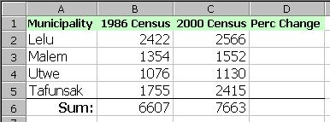
8c. Short essay, opinion based, use the back of this paper: Why did the municipalities grow at different rates, that is, why is one growing so much faster than the others and why are two growing so slowly?

