1. Start with Microsoft Excel. Enter the data shown and produce an XY Scatter graph with the equation of the best fit line displayed on the graph. The table is the price in dollars versus size in milliliters (ml) for soy sauce on Pohnpei this past Spring term.
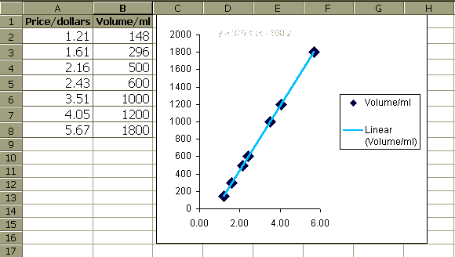
2. Calculate the predicted size in milliliters of a $3.00 bottle of soy sauce: ________
3. Calculate the predicted price of a 1500 milliliter bottle of soy sauce: ________
4. Create the document seen below using Microsoft Word (the soy sauce bottle was created using c:\windows\pbrush.exe Do not go for a perfect match, just a crude representation of the bottle).


The following is an analysis of the price versus size for soy sauce on the island of Pohnpei during April 2003. This consumer price study involved the following stores:
- 4TY
- Ace Commercial
- Ambros
- Best Buy
- Nakasone
- Palm Terrace
- Wall Mart

Price/dollars | Volume/ml
1.21 | 148
1.61 | 296
2.16 | 500
2.43 | 600
3.51 | 1000
4.05 | 1200
5.67 | 1800
5. Create a PowerPoint slide using the same Excel Data. Use any background. Copy and paste your graph from Excel into PowerPoint.

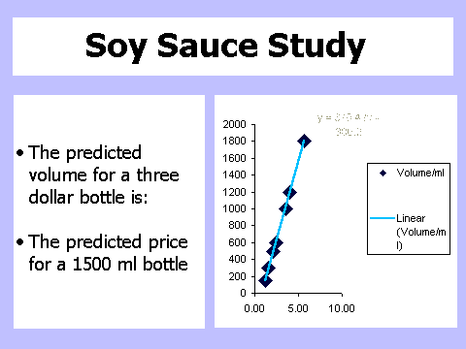

6. Use Google to run a search on the phrase: “Why Kosrae is Eroding” and write down the URL address of the number one search result:

7. Go to the page found in number six. Two-thirds of the way down the page the author lists “Human related causes of coastal erosion.” Briefly list three of the reasons given for human related causes of coastal erosion on Kosrae.

